Physics 1
Question 1
1.2 Energy and efficiency

The table gives data for three different types of light bulb.

Type of light bulb | Power input | Efficiency
Tungsten filament | 60 W | 2.5%
Compact fluorescent lamp (CFL) | 11 W | 13.6%
Light-emitting diode (LED) | 10 W

(a) (i) Calculate, in watts, the useful power output (light) of the tungsten filament bulb.
Write down the equation you need to use and show how you work out your answer. (2 marks)
(ii) Sketch a Sankey diagram for the tungsten filament bulb. (2 marks)
(b) Each of the bulbs produces the same useful power output. The LED lamp is slightly more efficient than the CFL.
(i) Explain why the tungsten filament bulb is much less efficient than either the CFL or LED bulb? (2 marks)
(ii) Calculate the efficiency of the LED bulb. Write down the equation you need to use and show how you work your answer out. (2 marks)
(iii) A householder is going to replace all of the tungsten filament lamps in the house with either CFL or LED bulbs.
What two pieces of information would the householder need in order to work out which type of bulb, CFL or LED, is the most cost effective? (2 marks)
Question 2
1.1 Energy transfer by heating process
1.2 Energy and efficiency

(a) The water for a bath is heated using a gas boiler from 16°C to 40°C.
The energy required to heat the bath water equals 18 144 kJ.
The specific heat capacity of water equals 4200 J/kg °C.
Calculate the mass, in kg, of water used to fill the bath.
Write down the equation you need to use and show how you work out your answer. (3 marks)
(b) When a householder receives a gas bill, the energy consumption will be given in kilowatt-hours.
18 144 kJ = 5.04 kilowatt-hours
If 1 kilowatt-hour of energy costs 15p, calculate the cost of heating the bath water.
Assume that the gas boiler is 90% efficient.
Write down the equation you need to use and show how you work out your answer. (3 marks)
Question 3
1.4 Methods we use to generate electricity

Electricity can be generated from both renewable and non-renewable energy sources.
(a) Name two renewable energy sources used to generate electricity. (2 marks)
(b) Nuclear fuel is a non-renewable energy source.
(i) One advantage of using a nuclear fuel over using coal or gas to generate electricity is that a nuclear fuel produces no pollutant gases. Give the reason why. (1 mark)
(ii) Give two advantages of using a nuclear fuel rather than a renewable energy source to generate electricity. (2 marks)
(c) Electricity is transferred from power stations to consumers along the network of cables and transformers known as the National Grid.
(i) Explain why both step-up and step-down transformers are essential to the National Grid. (3 marks)
(ii) Some of the cables used in the National Grid run underground. Give one advantage and one disadvantage of running the cables underground. (2 marks)
Question 4
1.5 Using waves

(a) Light is transferred as a transverse wave and sound as a longitudinal wave.
(i) Give one further example of a transverse wave. (1 mark)
(ii) Explain the difference between a transverse wave and a longitudinal wave. (2 marks)
(b) Light waves and sound waves can be diffracted.
(i) What happens to a wave when it is diffracted? (1 mark)
(ii) Explain why sound waves will diffract through an open doorway but light waves will not. (2 marks)
Question 5
1.5 Using waves

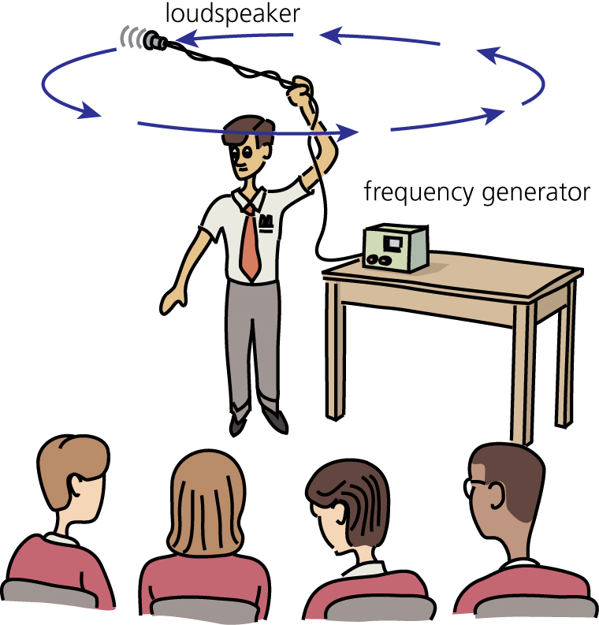
(a) The picture shows a teacher demonstrating the Doppler effect. As the teacher swings the loudspeaker around in a circle, the pitch of the sound heard by the students changes.

(i) What is the Doppler effect? (1 mark)
(ii) What determines the pitch of a sound? (1 mark)
(iii) Describe how the pitch of the sound heard by the students changes as the teacher swings the loudspeaker around in a circle. (2 marks)
(b) The light from most galaxies shows a red-shift. The teacher was using the moving loudspeaker as a model for red-shift.
(i) Why do scientists construct and use models in science? (1 mark)
(ii) In this model, what represents the galaxy and what represents the light emitted from the galaxy? (2 marks)
(iii) What can you conclude about a distant galaxy if the light observed from the galaxy shows a red-shift? (1 mark)
(c) Red-shift and cosmic microwave background radiation (CMBR) both provide evidence to support the ‘Big Bang’ theory.
Why is the significance of the evidence provided by CMBR to the ‘Big Bang’ theory? (1 mark)
Question 6
1.5 Using waves

(a) Table A gives typical wavelengths for different parts of the electromagnetic spectrum.
(i) Match each wavelength (J, K, L and M) with the correct part of the electromagnetic spectrum in Table B. (3 marks)

Table A

J | 5 × 10^{–7} m
K | 2 × 10^{–7} m
L | 1 × 10^{–9} m
M | 1 × 10^{–15} m

Table B

gamma
ultra violet
visible light
X-rays

(ii) The waves in which part of the electromagnetic spectrum given in Table B have a lower energy than waves in the ultra violet region? (1 mark)
(b) Some scientists are concerned that people who use a mobile phone frequently and for long periods of time might be damaging their own health.
(i) Explain why using a mobile phone might cause a health hazard. (2 marks)
(ii) Other scientists have said that mobile phones are not dangerous to health. Suggest why there is a difference of opinion among scientists as to whether mobile phones are a danger to health or not. (3 marks)

Answer 1
(a) (i)
useful power out =  = 1.5 W 
Writing out the equation helps achieve the correct substitution and final answer.
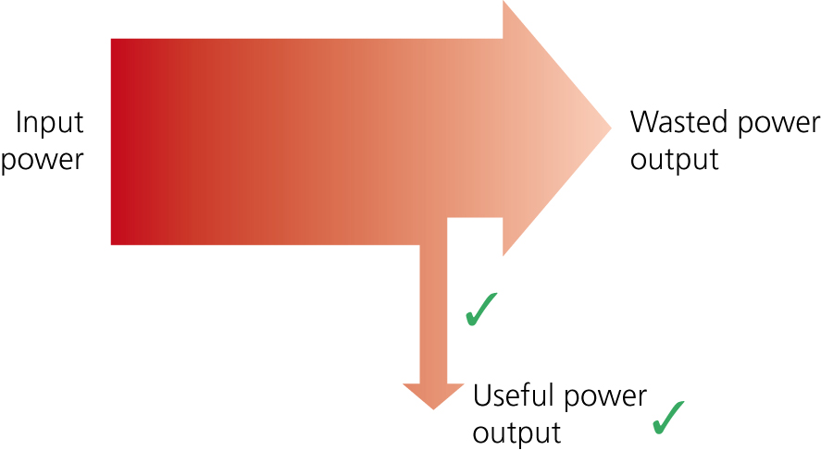
(ii)

The question asks you to sketch a Sankey diagram so there is no need to draw the diagram to scale. However, it is important to show the two output arrows having the appropriate relative widths. The two arrows must also be labelled, as in this answer.
(b) (i) The tungsten filament bulb operates at a much higher temperature than either the CFL or LED bulb.  So, a greater proportion of the input energy ends up warming the surroundings and being wasted. 
This question asks you to explain and is worth two marks, so two points need to be made. For the second point, it would have been acceptable to say that a greater proportion of the input energy is wasted as heat.
(ii) useful power out = power in × efficiency
60 × 2.5 = 10 × E_{LED} 
Efficiency of LED = 15% 
This answer uses an earlier piece of information given at the start of part (b), that the useful output power of each bulb is the same.
(iii) 1 The cost of each type of bulb. 
2 The number of hours each bulb is expected to last before it needs replacing. 
Remember that cost effectiveness and payback time are not the same thing.
Answer 2
(a) temperature rise = 40 – 16 = 24°C 
E = m × c × θ
 = 180 kg 
If you prefer, put in an extra step. Write down the rearranged equation first in symbol form and then substitute the numbers in. In this particular example, remember that the energy has been given in kilojoules (kJ) and so must be converted into joules.
(b)
 = 5.6 kWh 
cost = 5.6 × 15 = 84p 
To calculate the total energy in, the efficiency has been converted from 90% to 0.9.
Answer 3
(a) Tides  and waves 
Both of these answers involve water. However, an answer that simply said ‘water’ would not be good enough to be given a mark. Alternative answers include wind, solar and geothermal.
(b) (i) Because the nuclear fuel is not burned. 
Remember that nuclear fuels release energy by the process of nuclear fission. It is the fossil fuels — coal, oil and gas — that produce pollutant gases when burned.
(ii) It is a concentrated energy source  meaning that a small mass of fuel will release a lot of energy.
It is a reliable energy source. 
The question simply said ‘Give’, so there are no additional marks for explaining either advantage.
(c) (i) Step-up transformers increase the voltage and at the same time reduce the current in the cables.  This reduces the energy losses in the cable  and so increases the efficiency of the network. The step-down transformers are needed to reduce the voltage to a safe value for consumers to use. 
The first mark could have been gained for either ‘increase the voltage’ or for ‘decrease the current’. The question asks about both types of transformer, so the answer should refer to both.
(ii) One advantage of underground cables is that they can go through National Parks and other areas of natural beauty without being seen. 
A disadvantage of underground cables is that they are very expensive to install compared with overhead cables. 
It is unlikely that you would be asked to give more than two advantages or two disadvantages for either underground or overhead cables. It is also often the case that what is an advantage for one type of cable is a disadvantage for the other. This second answer gains the mark because it gives more detail than simply saying ‘more expensive’. This on its own would not be given a mark.
Answer 4
(a) (i) radio waves 
Any part of the electromagnetic spectrum could have been given; or water waves.
(ii) With a transverse wave the vibration causing the wave is at right angles to the direction of energy transfer.  With a longitudinal wave the vibration causing the wave is parallel to the direction of energy transfer. 
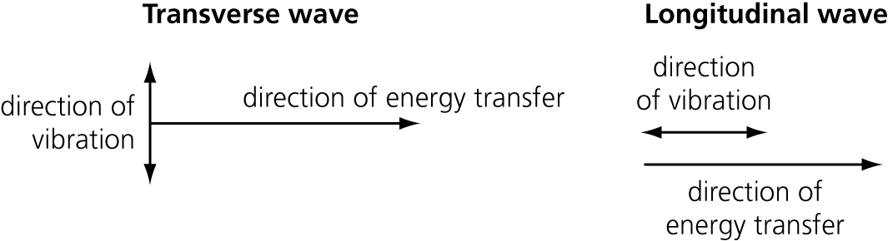
If you find it easier, you could give this answer as two labelled diagrams:

(b) (i) It spreads out. 
A simple statement is enough here.
(ii) Diffraction happens when the gap through which the wave travels is about the same size as the wavelength of the wave.  The width of the doorway is similar to the wavelength of a sound wave but is very much bigger than the wavelength of a light wave. 
This answer compares the wavelength of the two types of wave and relates this to the width of the gap.
Answer 5
(a) (i) The observed change in wavelength or frequency of a wave emitted from a source that is moving relative to the observer. 
This is a fairly formal definition of the Doppler effect but one that is worth learning. If you do learn it off by heart, make sure that you know what it means.
(ii) The frequency of the sound. 
Pitch and frequency are often taken to mean the same thing but in this case you need to know that there is a difference and that it is frequency that determines pitch.
(iii) As the loudspeaker moves towards the students the pitch increases.  As the loudspeaker moves away from the students the pitch decreases. 
The pitch will change depending on whether the loudspeaker moves towards or away from the students. So it is important that the answer describes both.
(b) (i) A model can help to explain a theory  or an effect.
A model does not have to be something physical as in this example. It can equally be an idea, like the kinetic theory model, or a mathematical equation.
(ii) The galaxy is represented by the loudspeaker  and the light is represented by the sound  emitted from the loudspeaker.
The answer covers both the galaxy and the light.
(iii) The galaxy is moving away from the Earth. 
If you are asked about blue-shift, it is the opposite of red-shift. A galaxy that shows blue-shift is moving towards the Earth.
(c) The ‘Big Bang’ theory is the only theory that can explain the existence of CMBR. 
You need to remember this. Things may change in the future but at the moment this is true.
Answer 6
(a) (i) J — visible light
K — ultra violet
L — X-rays
M — gamma 
You need to remember that the wavelengths of electromagnetic waves varies from about 1 × 10^{–15} metres (gamma rays) to more than 1 × 10⁴ metres (radio waves). Since gamma rays are given in Table B they must go with the shortest wavelength. The other types of wave then follow in order.
(ii) Visible light 
This is another area to remember: the order of the waves within the electromagnetic spectrum in terms of energy.
(b) (i) Mobile phones are designed to transmit and receive microwaves.  The energy absorbed from the microwaves might damage or kill body cells. 
The key idea in the first marking point is the link between mobile phones and microwaves.
(ii) Some studies have produced evidence that mobile phones are harmful to health  while the evidence from other studies would suggest that mobile phones are not harmful.  This means that there is no conclusive evidence supporting the view of either group of scientists. 
The answer is a balanced argument based on the variation of evidence available from different studies.

