Chemistry 1
Question 1
1.1 The fundamental ideas in chemistry

Group 1 elements burn vigorously when heated in oxygen.
(a) Complete these diagrams to show the electronic structures of sodium and oxygen atoms. (2 marks)
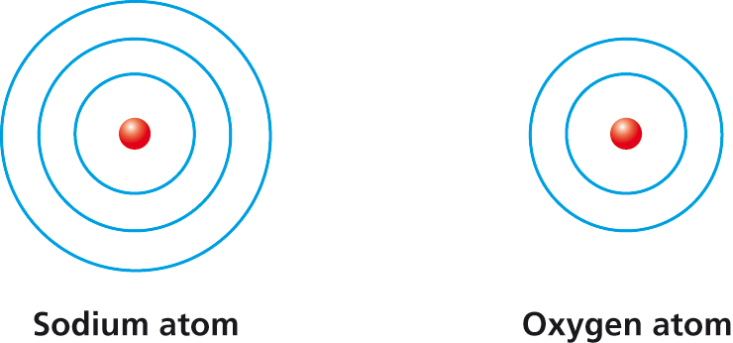
(b) Write the word equation that describes the reaction between sodium and oxygen. (1 mark)
(c) Write the balanced equation for this reaction, including the state symbols. (3 marks)
(d) Why are the elements in group 0 unreactive? (1 mark)
Question 2
1.2 Limestone and building materials

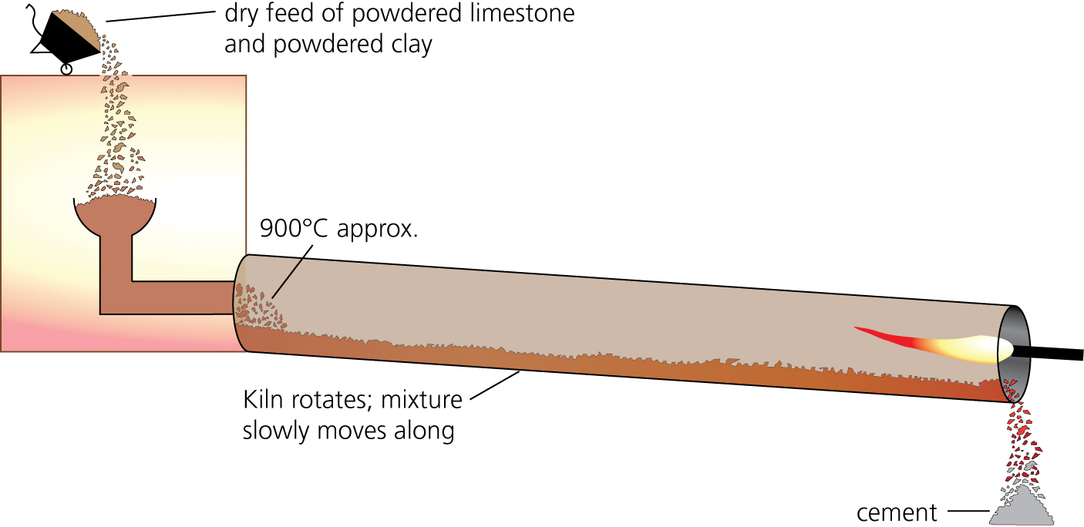

When limestone is heated to make cement it first reacts to produce lime (calcium oxide).
(a) Write a word equation using chemical names for what happens when limestone is heated. (1 mark)
(b) Write the chemical formula for:
(i) limestone (1 mark)
(ii) lime (1 mark)
(c) Write a balanced equation with state symbols for what happens when limestone is heated. (2 marks)

Water reacts with lime to form slaked lime (calcium hydroxide).
(d) Write a word equation for this reaction using chemical names. (1 mark)
(e) Write a balanced equation with state symbols for this reaction. (3 marks)
(f) Farmers use slaked lime for liming the soil. Why is it necessary to lime some soils? (1 mark)
Question 3
1.3 Metals and their uses

Copper can be obtained from solutions of copper salts by electrolysis or by displacement using scrap iron. It can also be extracted by phytomining.
(a) Draw an arrow on the following reactivity series (reactivity decreases down the list) to show where copper should be placed. (1 mark)
sodium
calcium
magnesium
aluminium
carbon
zinc
iron
(b) Write a word equation for the displacement of copper from copper sulfate solution by iron. (1 mark)
(c) Write a balanced equation with state symbols for this reaction. (3 marks)
(d) Explain why copper is produced at the negative electrode during electrolysis.
(2 marks)
(e) What is phytomining? (2 marks)
(f) Predict the method of extraction used to obtain calcium from its ore and explain your answer. (2 marks)
Question 4
1.4 Crude oil and fuels

Crude oil is a mixture of compounds, mainly hydrocarbons.
(a) What is a hydrocarbon? (1 mark)
(b) The table gives the boiling points of four hydrocarbons.

Hydrocarbon | Boiling point in °C
P | 174
Q | –161
R | 125
S | –42

Which of these hydrocarbons are gases at room temperature (20°C)? (1 mark)
(c) Which of these hydrocarbons has the largest molecules? (1 mark)
(d) Fractional distillation can be used to separate crude oil into fractions. Describe how this process works. (3 marks)
(e) Draw the structure of ethane, C₂H₆, showing all the bonds. (1 mark)
(f) Write a balanced equation for the complete combustion of ethane. (3 marks)
(g) The use of hydrocarbons as fuels can lead to acid rain. Explain how this arises. (3 marks)
Question 5
1.5 Other useful substances from crude oil

The cracking of large molecules involves their thermal decomposition.
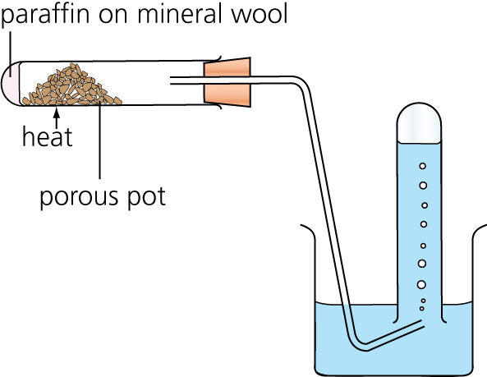
The diagram shows an apparatus that can be used to crack hydrocarbons in the laboratory.

(a) What is thermal decomposition? (2 marks)
(b) Why is the porous pot included in the apparatus? (2 marks)
(c) Complete the equation below for the cracking of the molecule C₂₀H₄₂. (1 mark)
C₂₀H₄₂ → C₃H₆ + _____________________
(d) What chemical test would you use to show that the gas, propene, was an alkene? (3 marks)
(e) Draw the structure of the propene (C₃H₆) molecule, showing all the bonds. (2 marks)
(f) Explain what is meant by polymerisation. (2 marks)
(g) Use a diagram to show the formation of poly(propene). (3 marks)

Crude oil is used to produce many useful fuels, but oil reserves are being used up. One way to conserve crude oil reserves would be to increase the production of bio-fuels.
Ethanol can be produced for use as a bio-fuel. Cars can be powered by ethanol or ethanol–petrol mixtures.
Sugar cane can be fermented to give a mixture of water (boiling point 100°C) and ethanol (boiling point 78°C).
The cost of producing ethanol by fermentation is very much higher than the production cost of petrol. It costs less to produce ethanol from crude oil (alkanes). In the production, the vapour of an alkane is passed over a hot catalyst to produce ethene. Ethene is then converted into ethanol.
(h) Describe how ethanol, C₂H₅OH, can be produced from ethene. (2 marks)
(i) Ethanol can be made using either sugar or alkanes as the starting material.
Evaluate the advantages and disadvantages of using these two starting materials to produce ethanol. (4 marks)
Question 6
1.6 Plant oils and their uses

(a) Describe why vegetable oils are an important part of our diet. (2 marks)

Some crisps are claimed to be healthier because they are cooked in sunflower oil.
A student found the following information about three oils that are used to make crisps. The iodine value is the mass (in grams) of iodine that reacts with 100 g of oil. Plant oils with lower iodine values are harder and are less unsaturated.

Oil | Iodine value
Olive | 82
Rapeseed | 113
Sunflower | 133

Oils are thought to be healthier if they are high in polyunsaturated fat.
(b) What is an unsaturated vegetable oil? (1 mark)
(c) Iodine solution reacts in the same way as bromine water. What would you see as the iodine reacts with each of the oils? (1 mark)
(d) Use the data in the table to decide which oil should be healthiest. Explain your answer by comparing this oil with other oils. (2 marks)
(e) Sunflower oil is a liquid and can be used to make margarine. Explain how it can be processed to make it suitable for such use. (5 marks)
Question 7
1.7 Changes in the Earth and its atmosphere

(a) What are the names of the main two gases in our atmosphere today? (1 mark)

Over 3 billion years ago, our planet’s atmosphere was mainly water vapour, carbon dioxide, methane and ammonia.
(b) Why is there now less water vapour in the atmosphere? (2 marks)

For the last 200 million years the amount of carbon dioxide in the atmosphere has remained almost the same.
(c) Describe the natural processes that remove carbon dioxide from the atmosphere. (4 marks)
To gain full marks in this question you need to use continuous prose. You will be marked on your ability to use good English, organise information clearly and use specialist vocabulary where appropriate.

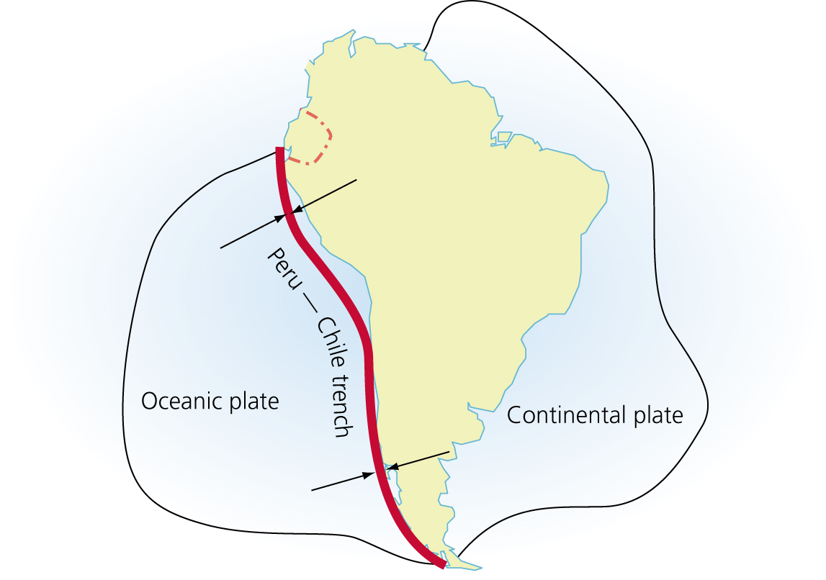
The diagram shows the Peru–Chile trench, which runs down the west coast of South America. It is the boundary between two tectonic plates that are moving towards each other.

(d) What causes the tectonic plates to move? (2 marks)
(e) How are earthquakes caused? (2 marks)

Answer 1
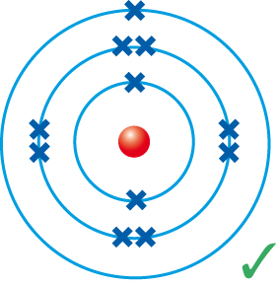
(a)
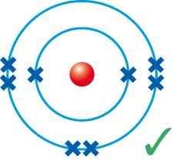
It is not essential to pair up the electrons but it really helps you to count the correct number and the examiner will be impressed by the neatness of your answer.
You can use either crosses or dots for electrons, but in each diagram you have to use all the same.
(b) sodium + oxygen → sodium oxide 
The question asks for the word equation, so do not use any symbols.
(c) 4Na(s) + O₂(g) → 2Na₂O(s) 
The 3 marks are allocated thus:
- 1 for the correct formulae, so pay attention to knowing how to generate the formulae of compounds and knowing the elements that are diatomic (H₂, N₂, O₂, F₂, Cl₂, Br₂, I₂, At₂)
- 1 for correctly balancing the equation
- 1 for using correct state symbols
(d) The elements in group 0 are unreactive because they have a full outer shell of electrons. 
At GCSE it is easiest to think of elements reacting in order to gain full outer shells.
Answer 2
(a) calcium carbonate → calcium oxide + carbon dioxide 
It is essential that you use the chemical names for all the substances in a word equation. Even for carbon dioxide, do not be tempted to use its formula, even though you may say it in your head as you are writing the word equation.
(b) (i) Limestone: CaCO₃. 
(ii) Lime: CaO. 
Writing these chemical formulae will help you with writing the chemical equation. Make sure your symbols are clearly the right style, i.e. upper case, lower case and subscript as appropriate. CaCO₃, not CaCO3 or CaCo₃.
(c) CaCO₃(s) → CaO(s) + CO₂(g) 
The 2 marks here are for the correct formulae and state symbols. It would probably be difficult to balance the equation if you had incorrect formulae from part (b).
(d) calcium oxide + water → calcium hydroxide 
Do not be put off by the use of the name ‘slaked lime’ if you have not seen it before. Just read the question carefully.
(e) CaO(s) + H₂O(l) → Ca(OH)₂(s) 
The 3 marks are allocated thus:
- 1 for the correct formulae
- 1 for correctly balancing the equation
- 1 for using correct state symbols (note that water is a liquid (l); remember that (aq) means dissolved in water)
(f) Farmers use slaked lime to reduce the acidity/increase the pH of the soil. 
You may not have been taught this but you should know that calcium hydroxide is alkaline (high pH).
Answer 3
(a) sodium
calcium
magnesium
aluminium
carbon
zinc
iron
← copper is here 
Copper has to be less reactive than iron in order for it to be displaced by iron. It therefore appears below iron in the reactivity series.
(b) copper sulfate + iron → copper + iron sulfate 
(c) CuSO₄(aq) + Fe(s) → Cu(s) + FeSO₄(aq) 
You have not been given any formulae in this question. It is therefore vital that you either know the formulae of compounds you have come across or that you can work them out from the charges on ions found on the datasheet provided in the exam.
2 marks are awarded for the correct formulae (right-hand side and left-hand side of the equation) and 1 mark is for using the correct state symbols.
(d) Copper forms Cu²⁺/positive ions.  Positive ions move towards the negative electrode during electrolysis. 
‘Explain’ in a chemistry question can be thought of as ‘given reasons why…’. These reasons can be very short sentences or bullet points. You should not use up space or time in repeating the question.
(e) Phytomining uses plants to absorb metal compounds.  The plants are then burned to produce ash that contains the metal compounds. 
This is a question that requires a straight quote from the specification for full marks. Learn such definitions.
(f) Electrolysis.  Because calcium is very reactive. 
Answer 4
(a) A hydrocarbon is a compound made up of hydrogen and carbon only. 
Learn this definition and remember the ‘only’.
(b) The gases are Q  and S .
A substance is a gas when it is at or above its boiling point.
(c) P has the largest molecules.  It has the highest boiling point.
(d) Fractional distillation works by:
- evaporating the oil 
- allowing it to condense 
- at a number of different temperatures 
You will find this in the specification. Simple statements of fact are all that the examiner requires of you.
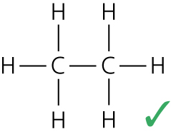
(e)

Draw all structures carefully, making sure the bonds are accurately between the relevant atoms.
(f) C₂H₆(g) + 3½O₂(g) → 2CO₂(g) + 3H₂O(g) 
or
2C₂H₆(g) + 7O₂(g) → 4CO₂(g) + 6H₂O(g) 
The 3 marks are allocated thus:
- 1 for the correct formulae
- 1 for correctly balancing the equation
- 1 for using correct state symbols (note that here water is a gas (g); the reaction is hot enough to make steam)
(g) Hydrocarbons contain sulfur (as an impurity).  The sulfur burns (along with the hydrocarbons) to form sulfur dioxide.  The sulfur dioxide causes acid rain. 
Answer 5
(a) The breaking down of a molecule  using heat .
(b) It is a catalyst  and speeds up the reaction .
(c) C₂₀H₄₂ → C₃H₆ + C₁₇H₃₆ 
(d) Use bromine water.  It would change from orange  to colourless .
Always note both the original and final colours when describing colour changes. ‘Clear’ would not score a mark. Remember, water is clear and colourless; copper sulfate solution is clear and blue.
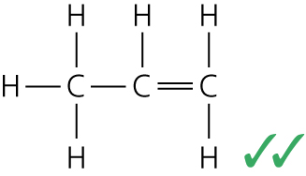
(e)
Draw all structures carefully, making sure the bonds are accurately between the relevant atoms and double bonds are clearly two lines.
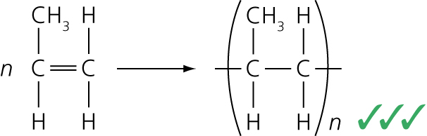
(f) Many small molecules (monomers)  join together to form very large molecules .
(g)
The marks are for:
- correct propene structure (as here or in part (e))
- correctly placed ‘n’ on both sides
- brackets around the two-carbon unit, with CH₃ on one of the carbons and two bonds extending through the brackets
(h) Ethene is reacted with steam  in the presence of a catalyst .
(i)
 | Advantage | Disadvantage
Ethanol from sugar | Conserves crude oil reserves | Have to separate the ethanol from water — uses energy
Ethanol from sugar | Uses renewable resources | Land used to grow sugar cannot be used to grow food
Ethanol from alkanes | Cheaper than ethanol from sugar | Have to use energy to crack the alkanes
Ethanol from alkanes | Pure product | Ethene has to be further reacted to produce ethanol

An evaluation question is best tackled by using a table. Look at the question; there are two methods and you have to evaluate the advantages and disadvantages of them both. That makes a table with four sections and there are 4 marks available for your answer. A valid comment in each section will score maximum marks. Make sure you do not use the same point twice — for example ethanol from sugar conserves crude oil (advantage) is the same as ethanol from alkanes uses up crude oil (disadvantage).
Answer 6
(a) They provide energy  and nutrients .
(b) One that contains double carbon–carbon (C=C) bonds. 
(c) It will lose its colour. 
You have not been told what colour iodine solution is, so do not guess. You do know that: bromine reacts with C=C bonds in the test for unsaturation; iodine is in the same group (group 7); and elements in the same group have similar chemical reactions.
(d) Sunflower oil because it has the highest iodine value , which indicates that it is more unsaturated than the other two oils .
(e) Unsuitable because it will be too soft/liquid at room temperature (an oil, not a fat) .
Process: react with hydrogen  at about 60°C  with a nickel catalyst . Suitable now because its melting point is higher, so it is harder. 
This question is worth 5 marks; make sure you make five valid points, answering each part of the question in turn.
Answer 7
(a) Nitrogen and oxygen 
You are asked for the names, do not give the formulae or chemical symbols.
(b) The water vapour cooled  and condensed to form the oceans .
(c) Using continuous prose and stating at least two ideas will score 1 mark. This is the ‘good English’ mark. Any three from this list (still working in prose) score 1 mark each:
- Plants take in carbon dioxide.
- Carbon dioxide is locked up in fossil fuels/coal/oil etc.
- Oceans remove carbon dioxide by reacting with it.
- The reaction produces carbonates/hydrogencarbonates.
- Carbonates form sedimentary rocks/are used to make shells.
The front page of the exam paper will tell you for which question you need to use continuous prose. You will be marked on your ability to use good English, organise information clearly and use specialist vocabulary where appropriate.
You can still think in terms of making 3 valid points; you just have to put them in linked sentences, remembering to use ‘specialist vocabulary’ such as ‘reaction’, ‘carbonates’ and sedimentary rocks’. For example: ‘Plants absorb carbon dioxide from the atmosphere, oceans also remove carbon dioxide by reacting with it. This reaction produces carbonates, which form sedimentary rocks.’
(d) Convection currents within the Earth’s mantle  driven by heat released by natural radioactive processes .
(e) By sudden and disastrous movements of tectonic plates  at the boundaries between tectonic plates .

