OCR AS/A-level Year 1 Chemistry A exam practice answers
6 Basic concepts and hydrocarbons
1 (a) (i) (Free) radical substitution ✓
(ii) The bond breaks (i.e. fission) such that each atom in the bond retains one of the bonded electrons. ✓
e.g. Cl−Cl → 2Cl•
(iii) 1,2-dichloroethane ✓ and 1,1-dichloroethane ✓
(b) (i) It behaves as a nucleophile ✓ because it donates an electron pair to the C^{δ+} ✓
(ii)
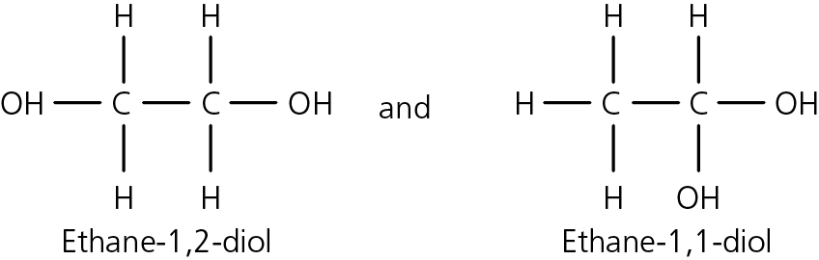
✓✓
2 (a) C : H : O
83.93/12 : 11.92 : 4.15/16
6.99 : 11.92 : 0.26 ✓
27 : 46 : 1
empirical formula = C₂₇H₄₆O
empirical mass = (12 × 27) + 46 + 16 = 386 ✓
Therefore, molecular formula also C₂₇H₄₆O ✓
(b) Secondary alcohol ✓ and alkene ✓
(c) (i) D ✓
(ii) E ✓
(iii) A ✓
(iv) B ✓
(v) C ✓
3 (a) (i) Hydrocarbons are compounds that contain carbon and hydrogen only. ✓
(ii) Liquids with different boiling points can be separated by fractional distillation. ✓
(b) (i) C₁₂H₂₆ = 144 + 26 =170 ✓
% C = (144/170) × 100 = 84.7% ✓
(ii) C₁₂H₂₆ → C₈H₁₈ + 2C₂H₄ ✓
(c) (i) A = 2,4-dimethylhexane ✓
B = 2,3,3-trimethylpentane ✓
C = 4-methylheptane ✓
(ii) BAC ✓
(iii) Branched chains prevent close packing ✓ and reduce the formation of van der Waals forces. The longer the carbon chain and the fewer the branches, the more van der Waals forces, hence the higher the boiling point. ✓
(iv) 2C₈H₁₈ + 25O₂ → 16CO₂ + 18H₂O
or
C₈H₁₈ + 12½O₂ → 8CO₂ + 9H₂O
1 mark for correct formulae ✓ and 1 mark for balancing ✓
(v) Any of: used as additives in petrol to increase the octane rating/burn more smoothly/reduce knocking/make less viscous/make more volatile. ✓
4 There are three processes — cracking, isomerisation and reforming — and each requires:
- an explanation
- an equation
- a statement as to their importance
It is possible to write the answer out in prose but probably easier using either bullet points or a table.
 | Explanation | Equation | Industrial importance
Cracking | Cracking is used to break down long-chain hydrocarbons into shorter-chain hydrocarbons and alkenes. High temperature and a catalyst are used. ✓ | C₁₀H₂₂ → C₈H₁₈ + C₂H₄ ✓ | Shorter-chain hydrocarbons are more volatile, less viscous and are more efficient fuels. ✓*  Alkenes are used in the petrochemical industry for producing polymers, alcohols and many other essential chemicals. ✓
Isomerisation | Isomerisation is used to convert straight-chain hydrocarbons into branched-chain hydrocarbons. ✓ | 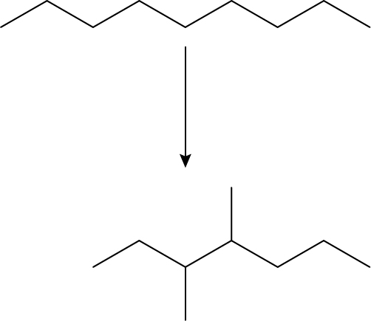  or any other branched isomer ✓ | The branched-chain hydrocarbons are added to petrol and increase the octane rating because they are more volatile, less viscous and are more efficient fuels. ✓*
Reforming | Reforming is the conversion of chain hydrocarbons into ring hydrocarbons. ✓ | 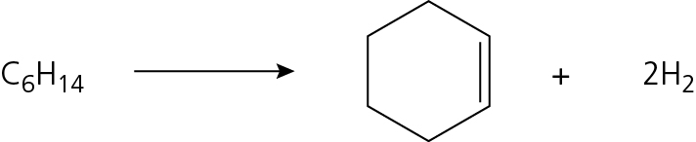  or a cyclic diene + 3H₂  or benzene + 4H₂ ✓ | Ring compounds are also added to petrol because they are more volatile, less viscous and burn more efficiently. ✓*
✓* mark awarded only once

