OCR AS/A-level Year 1 Chemistry A exam practice answers
5 Physical chemistry
1 (a) It is the enthalpy change when 1 mole of a covalent bond is broken ✓ in the gaseous state, which results in the formation of neutral particles. ✓
X−Y(g) → X(g) + Y(g)
(b) (i) HCl(g) → H(g) + Cl(g) ✓
(ii) ¼ ✓{CH₄(g) → C(g) + 4H(g)} ✓
This is difficult (hence 2 marks) because there are four C−H bonds, which are all different (see below) and it is the average C−H bond enthalpy that is used.
CH₄(g) → CH₃(g) + H(g) ΔH = +425 kJ mol⁻¹
CH₃(g) → CH₂(g) + H(g) ΔH = +470 kJ mol⁻¹
CH₂(g) → CH (g) + H(g) ΔH = +416 kJ mol⁻¹
CH(g) → C(g) + H(g) ΔH = +335 kJ mol^{–1}
The total enthalpy change is (+425 + 470 + 416 + 335) = +1646 kJ mol⁻¹, which is the enthalpy change when four C−H bonds are broken in methane and, therefore, the enthalpy change when one C−H bond is broken is +1646/4 = 411.5 kJ mol⁻¹.
(c) (i) Bonds broken (610 + 1640 + 436) = +2686 ✓
Bonds formed (–350 – 2460) = −2810 ✓
Enthalpy change = −124 kJ mol⁻¹ ✓
(ii) The bond energies used in the calculation are average values ✓ for the bonds, such that the C−H bond in ethene and ethane were assumed to be the same when in fact the C−H bond enthalpies will be different because they are in different environments ✓.
(d) The Ni catalyst is a heterogeneous catalyst, which speeds up a reaction without being used up. The ethene and hydrogen gases are adsorbed onto the surface of the Ni ✓, bonds are weakened (activation energy is lowered) ✓, the reaction takes place and the ethane is desorbed ✓.
2 (a)
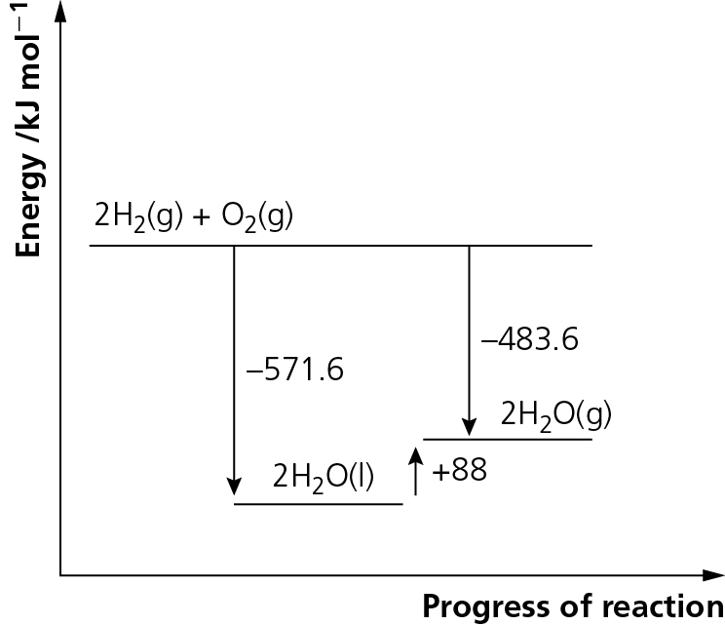✓✓
(b) From the diagram: 2H₂O(l) → 2H₂O(g) ΔH = +88 kJ mol⁻¹ ✓
Hence: H₂O(l) → H₂O(g) ΔH = +44 kJ mol⁻¹ ✓
3 (a) It is the enthalpy change when 1 mole ✓ of a substance is burnt completely, in an excess of oxygen ✓, under standard conditions of 298 K and 101 kPa (1 atmosphere) ✓.
(b)
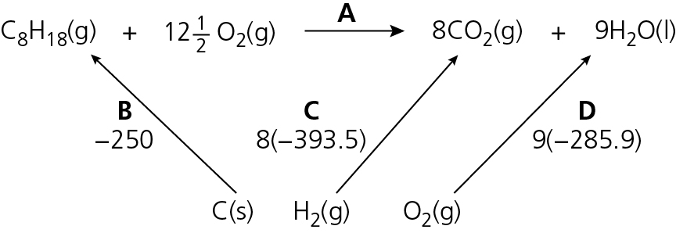
A + B = C + D
A = C + D – B
= (−3148) + (−2573.1) − (−250) ✓✓ = −3148 + 2573.1 + 250 = −5471.1 kJ mol⁻¹ ✓
(c) C₈H₁₈(l) + 8½O₂(g) → 8CO(g) + 9H₂O(l)
N₂(g) + O₂(g) → 2NO(g)
(d) (i) 2NO(g) + 2CO(g) → N₂(g) + 2CO₂(g) ✓
(ii)
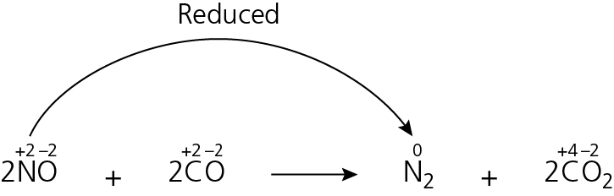
Nitrogen ✓ has been reduced because its oxidation state has changed from +2 to zero ✓.
4 (a) The rate of both forward and reverse reactions are the same ✓ and, therefore, the amount of each chemical remains the same (even though they are constantly interchanging) ✓.
(b) (i) The position of the equilibrium moves to the left ✓ because it favours the reverse reaction, which is endothermic ✓.
(ii) The equilibrium moves to the right ✓ because there are fewer molecules of gas on the right-hand side ✓.
(iii) Low temperature (because the forward reaction is exothermic) ✓ and high pressure (because there are fewer moles of gas on the right) ✓.
(c) (i) Temperature: a compromise is reached between rate and conversion. ✓ At low temperature the rate is too slow and therefore a higher temperature is used even though the percentage conversion is lower. ✓
Pressure: a compromise is reached between cost and conversion. A moderate pressure is used even though the percentage conversion is lower (also the rate is slower) because high pressure increases cost and decreases safety. ✓
(ii) The catalyst speeds up the reaction but doesn’t change the equilibrium position ✓ because it speeds up the forward and the reverse reactions equally, so the percentage conversion is the same ✓.
(iii) More cost efficient/less waste ✓ and reduces the amount of SO₂ pollution ✓.
5 (a) (i) The marking points are: products at a lower enthalpy than the reactants ✓; activation energy of forward reaction correctly labelled ✓; activation energy of reverse reaction correctly labelled ✓
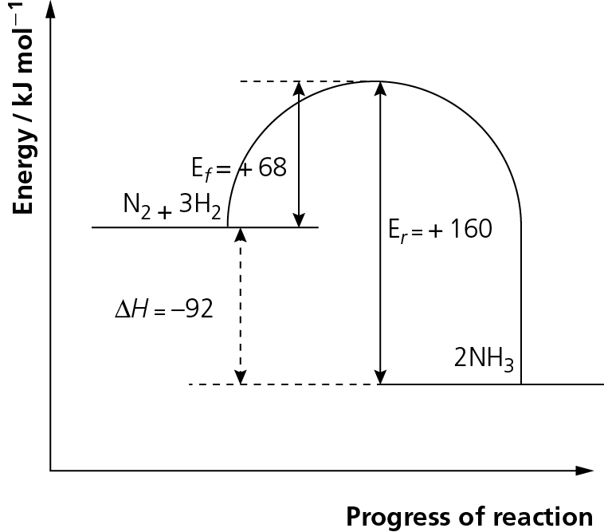
(ii) Activation energy is the minimum energy required to start a reaction. ✓
(iii) −92 kJ mol⁻¹ ✓
(b) (i) The N in NH₃ is −3 ✓ and the N in HNO₃ is +5 ✓. An increase in oxidation number involves a loss of electrons, which is oxidation (OILRIG). ✓
(ii) Le Chatelier’s principle states that if a closed system under equilibrium is subject to a change, the system will move in such a way as to minimise the effect of the change. ✓
(iii) Temperature: the forward reaction is exothermic ✓ and so will be favoured by low temperature ✓.
Pressure: there are more moles of gas on the right ✓so if a low pressure ✓ is used the system moves to the right.
(iv) Re-used/recycled in stage 2 ✓
(c) Acids are proton/H⁺ donors ✓; HNO₃ is a strong acid because it completely dissociates ✓ into its ions:
HNO₃ → H⁺ + NO₃⁻ ✓
6 (a) The marking points are:
- use the equation Q = −mcΔT ✓
- mass = 150 ✓
- calculate value of Q ✓
- moles of ethanol ✓
- divide value of ΔH by moles of ethanol ✓
- correct units ✓
ΔH = −mcΔT
moles of ethanol = 1.6/46 = 0.0347826087 = −(150 × 4.2 × 49)
ΔH = −30.87/0.0347826087 = −30870 J = −30.87 kJ
= −887.5125 = 888 (to 3 s.f.) kJ mol⁻¹
It is important in any calculation not to round during the calculation and only round at the end.
(b) Heat loss is the most significant error ✓, which could be improved by lagging the apparatus. Incomplete combustion ✓ — CO or C may have been formed ✓, which could be reduced by increasing the supply of oxygen to ensure that CO₂ is always produced ✓.
(There are 2 marks for the errors and 1 mark for either improvement.)
Students often criticise apparatus without carefully considering the error. Given that the temperature rise was approximately 50°C, if the thermometer used measured to the nearest degree, then the percentage error in measuring the temperature rise would be of the order (1/50) × 100 = 2%. Given the inaccuracy of the experiment this is not a significant error.
(c) There are many examples that could be used. The mark scheme shown below would be applied to all answers. The marking points are:
- Identification of a suitable example of a homogeneous catalyst. ✓ Suitable use for product. ✓
- Identification of a suitable example of a heterogeneous catalyst. ✓ Suitable use for product. ✓
Any two from:
Catalysts lower activation energy. ✓ Catalysts reduce costs because less energy is required. ✓
Catalysts are not used up and so can be used again. ✓
7 (a) the equilibrium mixture would turn from orange to red ✓ because by adding an acid the H⁺(aq) concentration on the left-hand side is increased, so the equilibrium moves to the right to minimise the effect of the added H⁺(aq) ✓
(b) The mixture would turn orange ✓ and then red ✓ because by adding an acid the OH⁻(aq) reacts with the H⁺(aq) on the left-hand side ✓ and decreases the concentration; the equilibrium moves to the left to minimise the effect of the added OH⁻(aq) ✓

