OCR AS/A-level Year 1 Chemistry A exam practice answers
1 Practical skills
1 (a) (i)
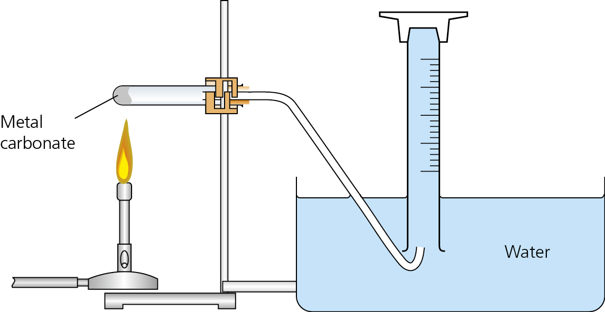✓✓
(ii) Weigh impure MgCO₃(s) and place as shown in apparatus. Heat MgCO₃(s) until no more gas evolved. (Immediately remove delivery tube from water to prevent suck-back.) ✓ Use volume of CO₂(g) collected to calculate moles of CO₂(g), ✓ which is the same as the moles of pure MgCO₃(g); hence calculate mass of pure MgCO₃(s) ✓. Calculate % purity by comparing mass of pure and impure MgCO₃(s). ✓
(iii) CO₂(g) is soluble in water. ✓
(iv) Collect gas in a syringe rather than by displacement of water. ✓
(b) (i) Weigh a crucible ✓, add impure MgCO₃(s) and reweigh ✓. Place crucible and contents on pipeclay triangle and heat for 5 minutes ✓, cool and weigh ✓. Repeat heating, cooling and weighing until constant mass is achieved. ✓
(ii) The accuracy of a 2-decimal-place balance is +/− 0.05 g. ✓ The crucible has to be weighed before and after heating so the error is 2 × 0.05 = 0.1 g; hence % error is 50%. ✓
2 (a) Graph — axes labelled ✓ and plotted using appropriate size/scale ✓. Tangent drawn correctly ✓ and gradient calculated correctly ✓
(b) (i) mass of Li = 12.68 − 12.56 = 0.12 g✓
error = 0.005 × 2 = 0.01 g ✓
% error = 8.3%
(ii) volume of H₂ % error = (1/240) × 100 = 0.42%
(c) The largest error is the weighing of the Li ✓. Use a more accurate balance ✓ to reduce the percentage error ✓ or use a greater mass of Li ✓, which would also reduce the % error ✓. There are also important procedural errors in that when the Li is added to the conical flask H₂(g) would be lost before the stopper is replaced (any suggestion to remedy this is acceptable)/lithium reacts with the air and would be coated in a layer of lithium oxide/nitride.

