OCR AS/A-level Year 1 Biology A exam practice answers
6 Biological membranes
1 (a) These molecules move by simple diffusion from a high concentration to a lower concentration. [2]
(b) Endocytosis — the plasma membrane folds inwards, surrounding the molecule in
a small vacuole. [3]
2 (a)
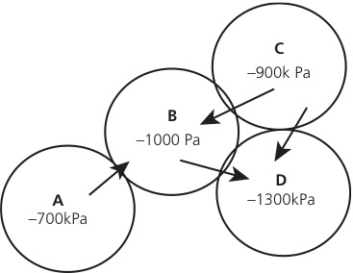 [4]
(b) Cell C has a lower water potential than pure water. Water will move into the cell by osmosis. The water will move down its water potential gradient. [3]
3 (a) Cholesterol stabilises the phospholipid bilayer, making it less fluid. [1]
(b) A glycoprotein is a binding site. [2]
(c) Phospholipids produce a barrier to movement of polar molecules. [2]
4 Vesicles have specific address proteins in their membrane. These address proteins have a specific shape, which is complementary to receptors. Receptors are found on the membrane of the correct organelle. [4]

