Edexcel AS/A-level Year 1 Economics A exam practice answers
7 Aggregate supply (AS)
1 Production is the total output of goods and services, and productivity is output per unit of input. [2]
2
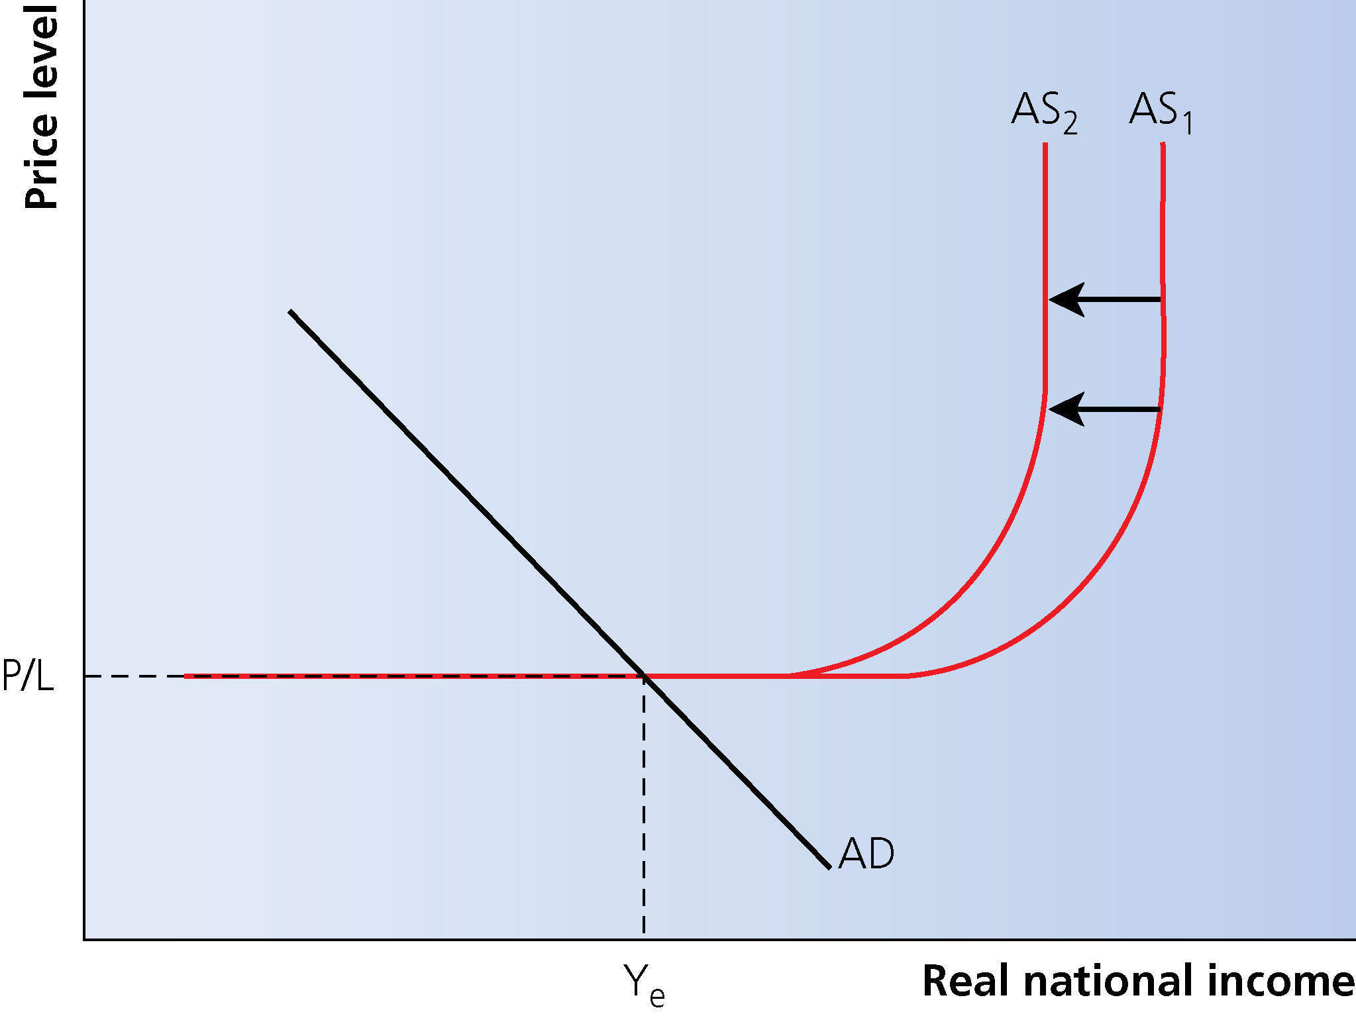
[2]
3 Correct answer B: a strong currency makes imports cheap. For a country that imports a lot of raw materials such as oil, a stronger currency will result in costs of production falling. It might also increase the amount of capital goods bought from abroad and might encourage immigration, both of which increases the factors of production in the country, which shifts out the long-run AS. [1]

