Edexcel AS/A-level Year 1 Economics A exam practice answers
10 Macroeconomic objectives and policies
1 For this question you need to identify two groups within society and show the impact on each group. For example: when interest rates are raised it can make savers better off and borrowers worse off, so people with more wealth will get richer relative to those with less money. [2]
2 It is a tax on spending, such as VAT. [2]
3 Correct answer A: increased tax leaves people with less disposable income so AD falls, and there is increased costs to firms who have to pay some of the tax (depending on elasticities), so AS also decreases. [1]
4 A supply side policy is any action taken by firms to increase the amount firms produce at any price level. An example is deregulation: when governments reduce the obstacles firms face in running their businesses firms will be willing to produce more or produce at lower prices. The impact can be shown by a shift to the right of the aggregate supply curve:
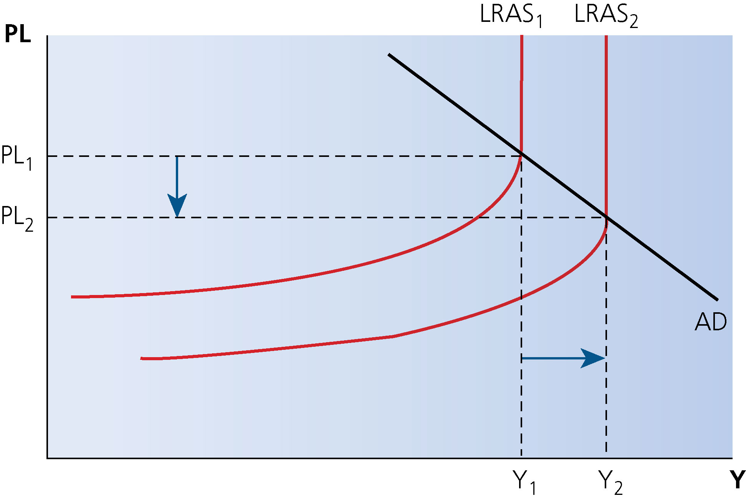

This answer would earn you 2 marks for definition, 2 for application to deregulation, and 2 marks for diagram. Make sure you annotate your diagram carefully with the price level (PL) and real national output (Y). Make it very clear that the price level falls and national output rises with some arrows. [6]
5 Nine marks are available for KAA. Youth unemployment refers to people under 24 willing and able to work, i.e. not in full-time education. Before looking at the solutions, consider the causes of youth unemployment, some of which are different from unemployment in general — the one major exception is that minimum wage levels, although lower for under 24s, still have a significant impact on firms’ costs.
- The credit crisis and recession: graduate recruitment has been cut as a result of the credit crunch from 2007 onwards. It is cheaper for firms to reduce employment levels by relying on the natural wastage of workers. Possible solution on the supply side: new banking regulations to prevent another crisis on this scale.
- Public sector cuts since 2010: the government has to spend less and real cuts have been made in spending on defence and the police, for example. The government specialises in services, which use a high degree of labour relative to output. Possible solution on the supply side: the government could delay its cuts in spending until the problem of youth unemployment has passed.
- Lack of qualifications: poor results in GCSE English and Maths correlate with higher unemployment in the under 24s. Possible solution on the supply side: spend more on education and training.
- Lack of experience, training and apprenticeships: taking on new workers is risky for firms who are also likely to have to invest in human capital for their younger workers. Possible solution on the supply side: governments could offer apprenticeships or give tax breaks to firms that offer training.
Evaluation: 6 marks are available for evaluation. The points you might make include:
- If the cause of youth unemployment is lack of aggregate demand (recession) then supply-side policies will not be very useful for addressing the problem.
- Supply-side policies might take a long time to work. For example, education and training costs at primary schools will take a decade to have an impact. Some might not work at all.
- Cutting minimum wages worsens problems of distribution of income.
- There is no evidence that cutting minimum wages increases employment.
- Government spending on education might not necessarily lead to more employable school leavers. It depends on what is going to be learnt and how the extra investment impacts upon the skills that firms need. [15]
6 For this question, 12 marks are available for KAA. Demand-side policies include fiscal and monetary policies and these must be expansionary. For example, the government could increase spending and lower taxes. G is a component of AD, therefore this will cause AD to increase. Consider a multiplier effect that causes AD to increase even more than the initial effect. Lower tax rates will increase consumer’ disposable income and therefore spending will increase.
On monetary policy, the MPC could cut interest rates making borrowing cheaper and encouraging spending rather than saving. This will also have the effect of increasing AD.
You could draw a diagram to show an increase in AD causing higher real GDP and a higher price level. Note there will only be an increase in real GDP if there is spare capacity in the economy — consider classical LRAS. If real GDP increases, then there may be higher demand for workers, as firms need to increase production to meet demand. Therefore, unemployment will fall. In the short run, the Phillips curve shows the trade-off between unemployment and inflation. As demand increases, there is lower unemployment with a trade-off of higher inflation.
Evaluation: 8 marks are available. Points might include:
- Classical economists disagree with this Keynesian analysis. They argue that the LRAS is inelastic or vertical in the long run. Therefore, an increase in AD will not cause a rise in real GDP.
- An increase in AD will cause an increase in real GDP in the short run. However, as prices increase, firms face an increase in their wage bill so the SRAS shifts to the left. This causes real GDP to return to its original level of output. Therefore, any fall in unemployment will only be temporary according to classical economists.
- Classical economist therefore believe that there is no trade-off as the Phillips curve suggests. This monetarist view became popular in the 1970s when there appeared to be a breakdown in the relationship between inflation and unemployment.
- It is also possible that demand-side policies fail to increase AD. In the Great Depression, cuts in taxes did not increase AD because consumer confidence was very low so fiscal policy failed to reduce unemployment.
- Cyclical unemployment is only one cause of unemployment. Other types of unemployment include real wage or (classical unemployment). This occurs when trades unions force wages above the equilibrium, reducing demand for labour.
- The natural rate of unemployment refers to the supply-side factors such as structural and frictional unemployment. These types of unemployment occur even when the economy is at full output so they will not be reduced by demand-side factors.
Conclusion: if effective, expansionary demand-side policies can only reduce cyclical unemployment, which will occur during a recession. Classical economists argue that this is only short run, and the markets will clear of their own accord. Keynesians argue that ‘in the long run we are all dead’, and government intervention can shorten a recession and therefore reduce unemployment. Nevertheless, it may be important for the government to tackle different types of unemployment with supply-side policies. [20]
7 KAA 14 marks. Points might include:
- Demand side policies include fiscal and monetary policies and these must be expansionary.
- Fiscal policy: the government could increase spending. G is a component of AD, therefore this will cause AD to increase. Consider a multiplier effect causing AD to increase even more than the initial effect.
- Fiscal policy: lower tax rates will increase consumers’ disposable income and therefore spending will increase.
- Monetary policy: the MPC could cut interest rates, which makes borrowing cheaper and encourages spending rather than saving. This will also have the effect of increasing AD.
A diagram will add value to the answer but is not compulsory: show an increase in AD causing higher real GDP and a higher price level. Note there will only be an increase in real GDP if there is spare capacity in the economy — consider classical LRAS.
There must be a link throughout the answer to unemployment: e.g. if real GDP increases then there may be higher demand for workers, as firms need to increase production to meet demand. Therefore, unemployment will fall
Evaluation: 6 marks. Points might include:
- The Phillips curve shows the trade off between unemployment and inflation. As demand is increased there is lower unemployment, with a trade off of higher inflation. It shows an opportunity cost of focusing on unemployment.
- Classical economists disagree with the Keynesian analysis. They argue that the LRAS is inelastic or vertical in the long run, therefore an increase in AD will not cause a rise in real GDP.

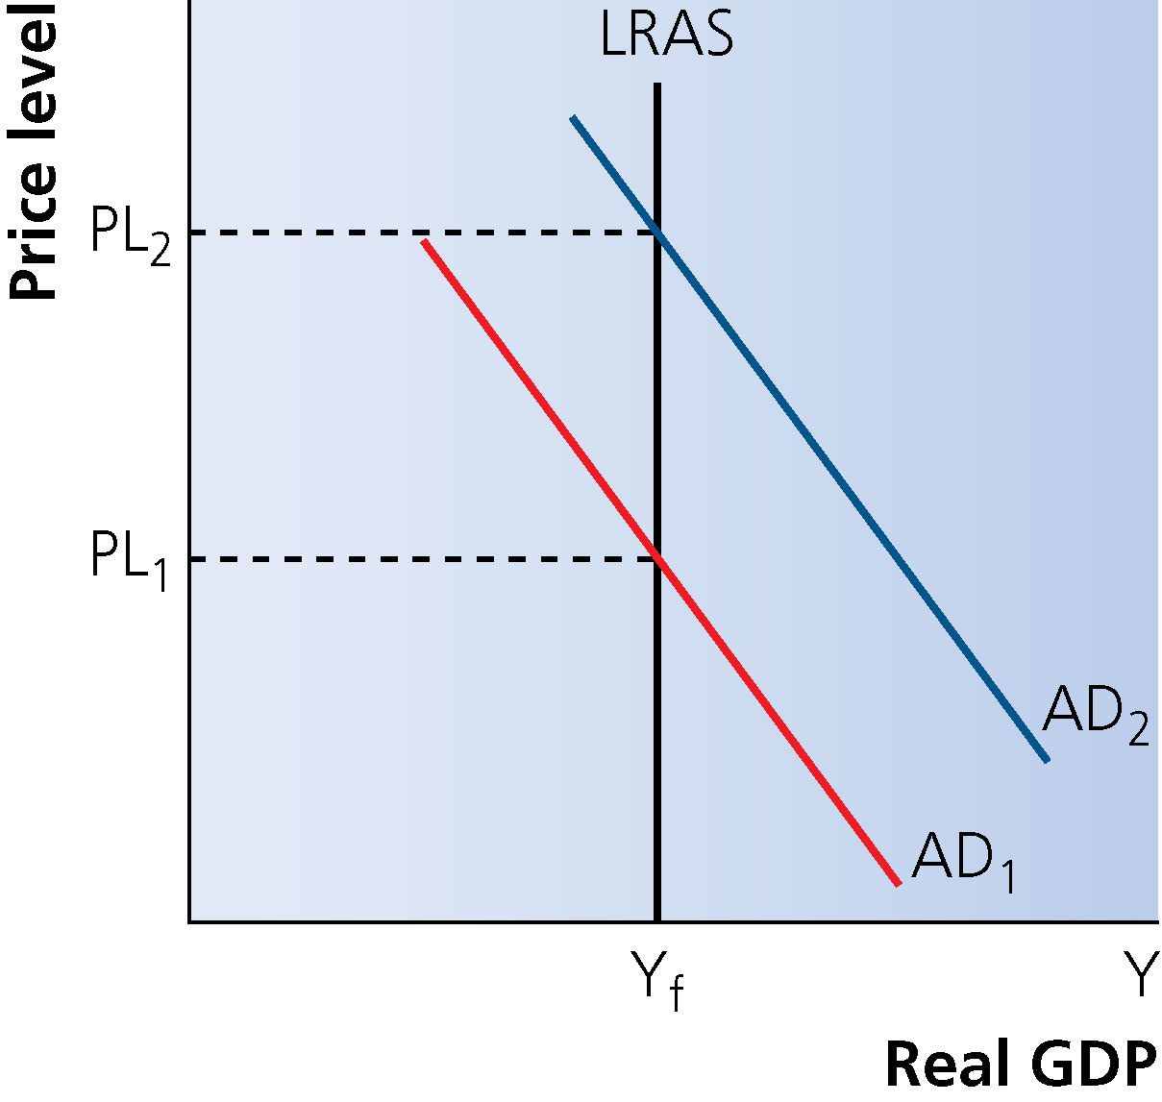
This diagram shows that an increase in AD will cause an increase in real GDP in the short run, and is useful for evaluation if you have used Keynesian analysis in the KAA part. As prices increase firms face an increase in their wage bill, so the SRAS shifts to the left. This causes real GDP to return to its original level of output. Therefore, any fall in unemployment will only be temporary according to classical economists.

