Edexcel AS Chemistry Exam practice answers

8: Energetics

1 (a) A stated temperature (allow 298¦K); 100¦kPa pressure for gases (allow 1¦atm); solutions at 1¦mol¦dm−3 — all three (✓) (✓); any two (✓)

(b) (i)

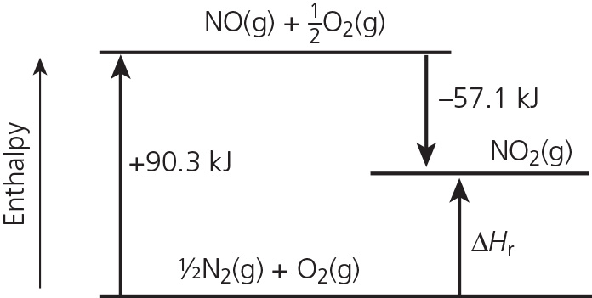

(✓) correct levels; (✓) labelled substances (✓)

(ii) +90.3 − 56.1 = +33.2¦kJ¦mol−1; sign and units; (✓) value (✓)

(c) B (✓)

2 (a) (i) The enthalpy change when 1¦mol of a substance is completely burnt/ burnt in

excess oxygen; (✓) under standard conditions of 100¦kPa (allow 1¦atm) pressure and at a stated temperature (✓) (allow at 298¦K)

(ii)

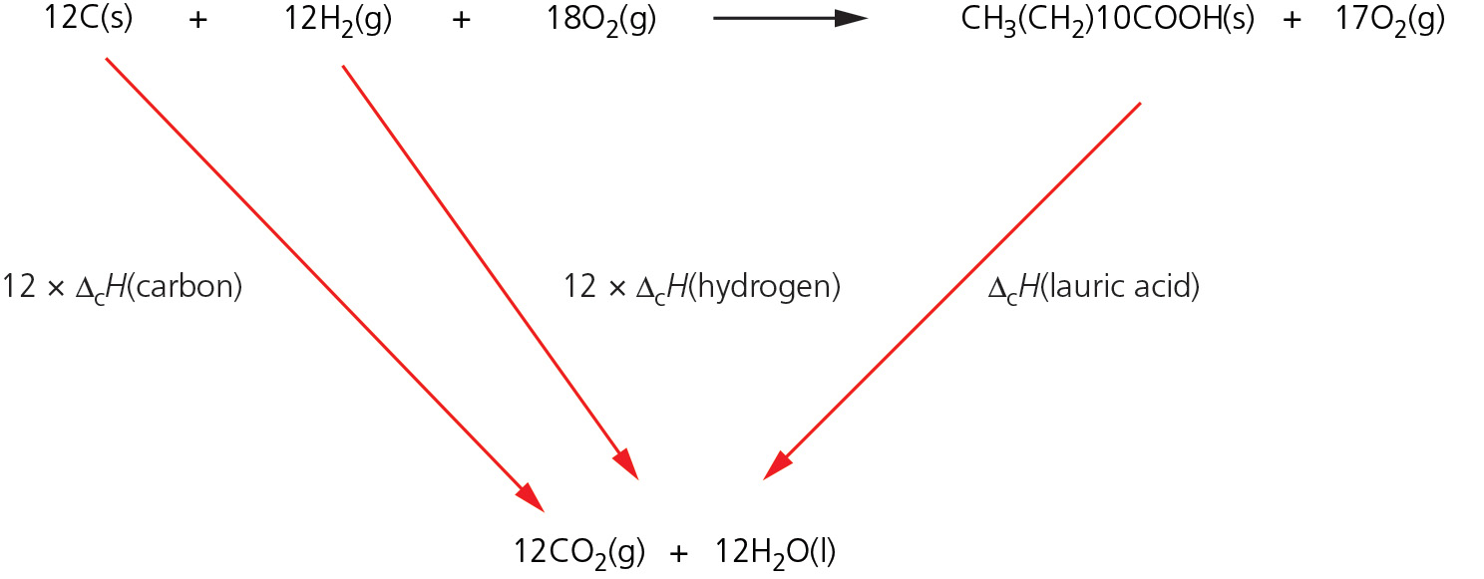

Hess Law diagram substances and arrows; (✓) labels (names or numbers) (✓)

Δf*H* = (12 × −394) + (12 × −286) − (−7377) = −783¦kJ¦mol−1

correct value; (✓) sign and units (✓)

(allow reversed right-hand arrow, but must be labelled ‘−Δc*H* lauric acid’)

(iii) B (✓)

(b) (i) The enthalpy change when 1¦mol of water is produced when an acid reacts with a base; (✓) at a stated temperature (allow at 298K) with all solutions at a concentration of 1¦mol¦dm−3 (✓).

(ii) Labelled axes and all points drawn; (✓) straight line from *t* = 6¦min extrapolated to *t* = 3¦min; (✓) Δ*T* = 11.4¦°C (✓)

(iii) Energy released = 50 × 4.18 × 11.4 = 2383¦J (✓)

amount of lauric acid  = 0.05¦mol (✓)

Δneut*H*  = −47¦700¦ J¦mol−1 = −4.77¦kJ¦mol−1 value; (✓) sign and units (✓)

3 (a) C (✓)

(b) (i) Breaking Making

C=C (+612) C–C (−347)

Br–Br (+194) 2 × C–Br (−580)

+ 806 (✓) − 927 (✓)

Δr*H* = +806 − 927 = −21¦kJ¦mol−1; value (✓)sign and unit (✓)

(ii) Average bond enthalpy values were used (✓)