Edexcel AS Chemistry Exam practice answers

6A, B, C: Introduction, alkanes and alkenes
1 (a) A ()
(b) (i) A homologous series is a series of compounds with the same functional group and the same general formula; () in which one member differs from the next by CH₂ ()
(ii) Amount of octane = 0.087¦72¦mol ()
Amount of oxygen needed = 12.5 × 0.087¦72 = 1.097¦mol ()
Volume of oxygen needed = 24 × 1.096 = 26¦dm³ ()
(c) (i) CH₄ + Cl₂ → CH₃Cl + HCl ()

(ii) Initiation:
()
Propagation: Cl• + CH₄ → HCl + CH₃•; () and CH₃• + Cl₂ →CH₃Cl + Cl• ()
Termination: any one of Cl• + Cl• → Cl₂ or Cl• + CH₃• → CH₃Cl or CH₃• + CH₃• →C₂H₆ ()
2 (a) (i) C ()
(ii) B () (O in OH has a higher priority than the C in CH₃ so it is the Z-isomer)
(b) (i) Add bromine water; () the red-brown solution goes colourless () (do not allow ‘goes clear’)
(ii) CH₃CH=CH₂ + Br₂ → CH₃CHBrCH₂Br ()
(c) (i) Electrophilic means that a species accepts a pair of electrons from another species and forms a covalent bond; () in addition two molecules react to form a single molecule ()
(ii)
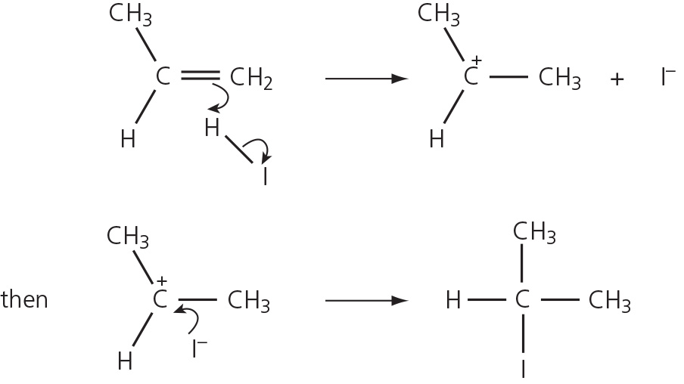
Both arrows in step 1; () arrow in step 2; () correct product ()
(iii) The primary CH₃CH₂CH₂⁺ intermediate ion is less stable than the secondary CH₃CH⁺CH₃ ion ()

(d)
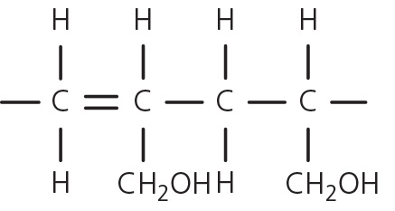
four-carbon chain; () rest of repeat unit with continuation bonds ()

6D, E: Halogenoalkanes and alcohols
1 (a) B ()
(b) (i) Orange solution goes green ()
(ii) The solution stays orange ()
(c) Propanoic acid ()
(d)
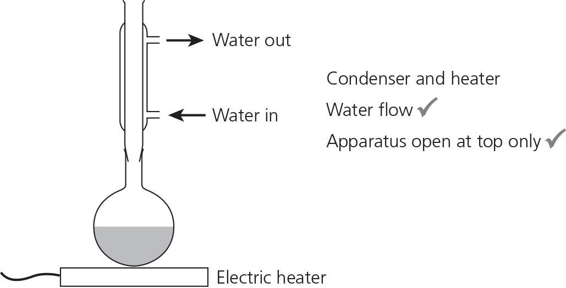
Condenser and heater; () water flow; () open at top only ()
2 (a) (i) C₂H₅Br + OH⁻ → C₂H₅OH + Br⁻ ()
(ii) C₂H₅Br + OH⁻ → CH₂=CH₂ + H₂O + Br⁻ ()
(b) (i) A nucleophile is a species with a lone pair of electrons; () that forms a covalent bond with a δ+ charged atom ()
(ii) D ()
(iii)
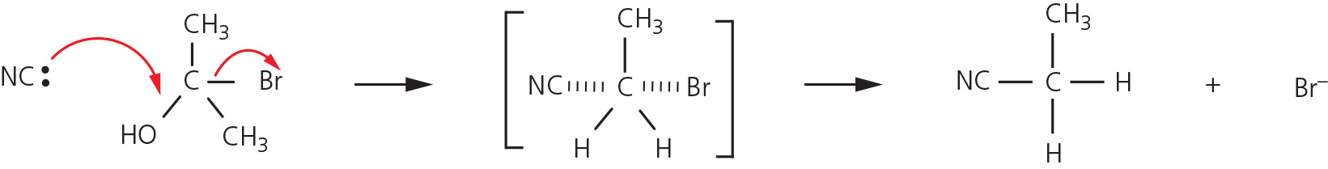
all species; () arrow from lone pair; () arrow from σ bond; ()
transition state; () arrow from transition bond ()
3 (a) D ()
(b) (i) H₂O/ water ()
(ii) A C–Br bond is weaker than a C–Cl bond; () so the activation energy is lower;
() and so the reaction is faster
(c) Add silver nitrate solution and warm; (); cream precipitate forms; () insoluble in dilute ammonia; but soluble in concentrated ammonia; ()
(d) 2NH₃ + CH₃CHBrCH₃ → CH₃CH(NH₂)CH₃; () + NH₄Cl()
(e) A ()

