Edexcel AS Chemistry Exam practice answers
1: Atomic structure and the Periodic Table
1 (a) B ()
(b) The relative isotopic mass is the mass of a single isotope of an element () relative to ¹/₁₂ the mass of a carbon-12 atom; () the relative atomic mass is the weighted average mass of the isotopes of the element ()
(c) C ()
(d) Let x be the fraction of ⁶⁹Ga
69.8 = 69x + 71(1 − x) ()
−2x = 69.8 − 71= −1.2 ()
x = 0.6 (or 60%) ⁶⁹Ga and 40% ⁷¹Ga ()
2 (a)
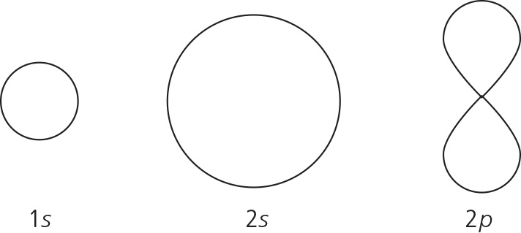 ()
(b) (i) C ()
(ii) Group 4; () a big jump in value; () between the 4th and 5th ionisation energies ()
(c)
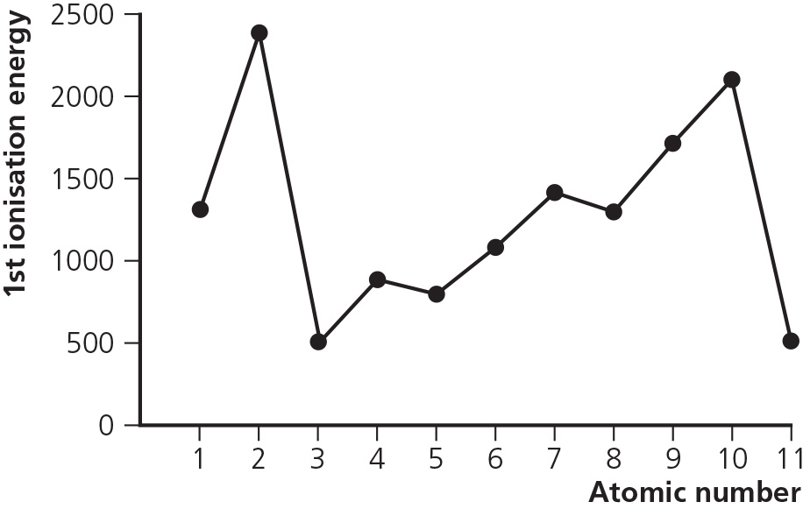
Axes labelled 1st IE on y-axis and atomic number on x-axis; () correct relative positions of first three elements; () rest of sketch ()
(d) (i) Electron removed from 2p; which is at higher energy level ()
(ii) Electron removed from one of a pair; so easier ()
(iii) 3s electron further from nucleus/ more shielded ()
(e)
 

