Edexcel AS Biology B exam practice answers
1 Biological molecules
1 (a) (Peptide) bond shown between carboxyl group of LH acid and amino group of RH acid; elimination of water shown.
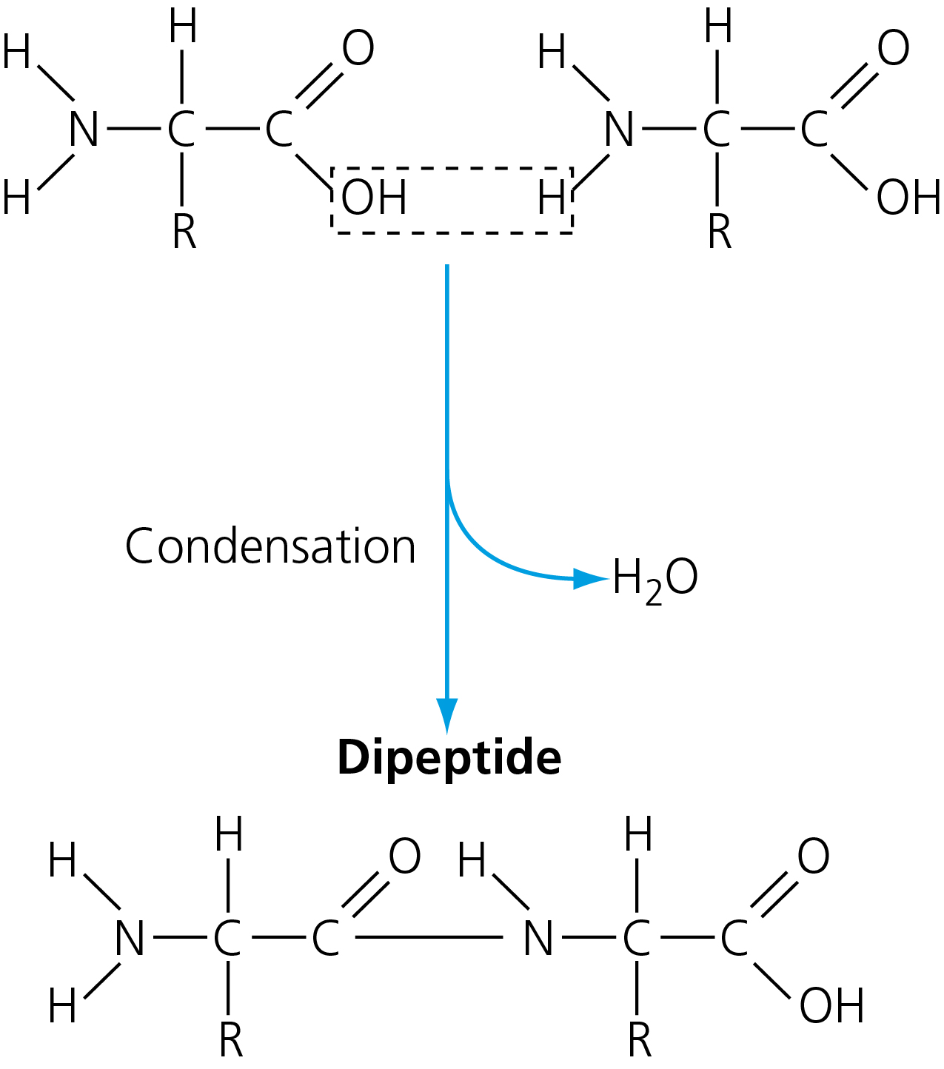 [2]
(b) Peptide. [1]
(c) Ionic bonds help to hold tertiary structure in place; pH changes the ability of amino acids to form ionic bonds; NH₂ becomes NH₃⁺/COOH becomes COO– and H⁺. [3]
2 (a) Disaccharide. [1]
(b) It reduces activation energy; by combining with substrate to produce enzyme–substrate complex. [2]
(c) Enzymes are specific (in the substrates with which they combine); amylase can hydrolyse α-glycosidic bonds (in glycogen and starch); amylase cannot hydrolyse β-glycosidic bonds (in cellulose). [3]
3 (a) A = glycerol; B = phosphate; C = fatty acid. [3]
(b) Head of phospholipid/phosphate group is hydrophilic; fatty acids are hydrophobic; so phospholipids form a bilayer (when water is present). [3]
4 (a) The enzyme concentration so that this remains constant throughout the investigation; pH/temperature because this affects enzyme activity. [2]
(b) Plot a graph of concentration of product against time; draw a tangent to the curve at time 0; find the gradient of this tangent. [3]
(c) A (sketch) graph shows the overall trend/the pattern more clearly. [1]
(d) At any one time during A, many enzyme molecules are unused; since the substrate concentration is too low/there are too few substrate molecules. [2]
(e) At any one time during B, all the enzyme molecules are in enzyme–substrate complexes; so none is free to bind with any substrates that might be added. [2]

5 (a) The original strands remain intact; each strand acts as a template for the production of a new strand. [2]
(b) The sequence of nucleotides in the template strand; hydrogen bonds form between specific base pairs; base pairs are adenine with thymine and cytosine with guanine. [3]
(c) The two strands are antiparallel; DNA polymerase catalyses the formation of phosphodiester bonds; can only add new nucleotides to carbon-3 of growing end of DNA. [3]
(d) DNA ligase; (catalyses the formation of) phosphodiester bonds (between fragments). [2]
6 This is an example of a free-response question. A good answer will contain any six of the following points (6 marks maximum):
- Water is the major component of most cells/organisms.
- Water is a reactant in many metabolic reactions/in hydrolysis reactions/in condensation reactions/in a correctly named reaction.
- Water is a universal solvent enabling metabolic reactions to occur faster in solution.
- The strong cohesion between water molecules enables a column of water to remain intact.
- The high specific heat capacity of water ensures that aquatic environments/the bodies of organisms remain relatively constant.
- The high latent heat of vaporisation ensures that the evaporation of water from the surface of organisms has a cooling effect.
- Its incompressibility enables water to support soft tissues/support gills/support plant tissues/act as a hydrostatic skeleton.
- The high surface tension of water enables organisms to live on water surfaces/enables organisms to live in air bubbles beneath water.
- The maximum density of water occurs at 4°C, so organisms can survive in water below surface ice. [6]

