AQA AS Physics exam practice answers
4 Mechanics and materials
1 tanθ = 6/10 = 0.6, so direction = 31° to the bank
speed = √(6² + 10²) = 11.7 m s⁻¹
Therefore:
velocity = 11.7 m s⁻¹ at 31° to the bank
2 resultant force = 300cos35 – 20 = 246 – 20 = 226 N
acceleration = 226/120 = 1.88 m s⁻²
3 (a) At maximum height (H) vertical velocity = 0
(b) velocity = 25cos30 = 21.7 m s⁻¹
(c) velocity = 25cos30 = 21.7 m s⁻¹
(d) H = u²sin²θ/2g = (625 × sin²60)/(2 × 9.8) = 23.92 m
(e) (i)
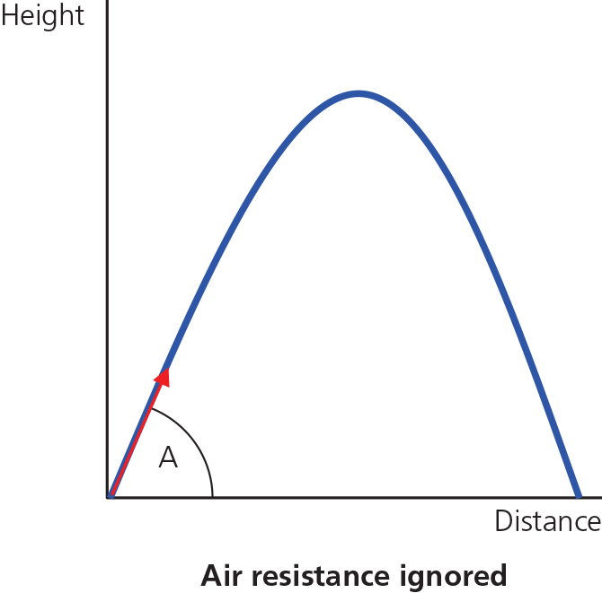

(ii)
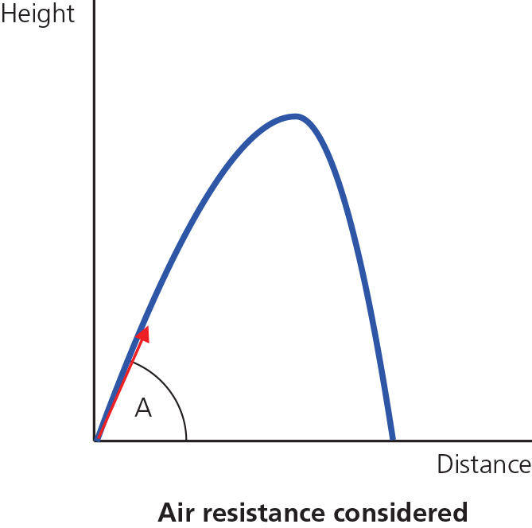
4 C
5 (a) 200 × 1.5cos55 = F × 3sin55
Therefore:
F = 70 N
(b) √(70² + 200²) = 212 N, direction tan⁻¹ (200/70) = 71°
(c) (200 × 1.5 + 70 × 9.8 × 1)cos55 = 3Fsin55
Therefore:
F = 230 N
6 (a) Force = 50 000 – 5000 = 45 000 N
(b) acceleration = 45 000/25 000 = 1.8 m s⁻²
(c) net force = accelerated mass × a = 8000 × 1.8 = 14 400 N
(d) net force of truck 9 on truck 8 = force of truck 8 on truck 9 = accelerated mass × a = 4000 × 1.8 = 7200 N
7 momentum conservation, 5 × 6 = (m + 5) × 0.5
mass of boy and skateboard, m = (30/0.5) − 5 = 55 kg
8 A
Set division on 2 lines
9 (a) momentum conservation, 0.8 × 25 + m × (−75) = 0
m = 20/75 = 0.27 kg
(b) kinetic energy = ½mv² = 0.5 × 0.8 × 25² = 250 J
(c) kinetic energy = ½mv² = 0.5 × 0.27 × 75² = 760 J
(d) To conserve momentum.
10 C
11 power = mgh/(efficiency × t) = (50 × 9.8 × 6)/(0.35 × 3) = 2800 W = 2.8 kW
12 (a) energy stored = ½Fe
F = eAE/L = (4 × 10⁻² × π × (0.375 × 10⁻³)² × 6.5 ×10⁹)/1.5 = 76.6 N
energy stored = ½Fe = 0.5 × 72.5 × 2 × 10⁻² = 0.75 J
(b) A sudden jerk attempts to give the line an acceleration, and this must be added to the 'static' tension. It breaks because it has to cope with a rapid acceleration as well as the simple weight of the fish.
13 B
14 pressure = ρgh = 2700 × 1.35 × 10¹² × h = 3.6 × 10⁶
h = 9.9 × 10⁻¹⁰ m = 0.99 nm

