AQA AS Economics exam practice answers
8 Economic performance
1 Disinflation occurs where there is a fall in the rate of inflation (i.e. prices are still rising but at a lower rate of increase). [3]
2 One mark can be awarded for the identification of each relevant issue and 1 mark for each accompanying explanation. Three issues are required. Relevant issues may include:
- Inflation is the percentage change in the price level over the period of 1 year.
- It is based on a basket of goods representing typical households’ expenditure.
- The basket of goods is weighted to represent different amounts spent on different goods.
- The basket is uprated each year, with new items added and some items removed when they become less relevant to households.
- The government has a target for inflation based on the CPI basket of 2% per year (+/−1%) [6]
3 One mark can be awarded for the identification of each relevant issue plus 1–2 additional marks for each accompanying development/explanation. Two issues are required. Relevant points could include:
- lower exchange rate leading to higher import prices
- higher VAT meaning firms mark-up their selling prices to maintain profit margins
- higher commodity prices will mean higher input prices for firms and prices rise to restore profit margins/cover costs [6]
4 Up to 4 marks can be awarded for a correctly drawn diagram, such as the following:
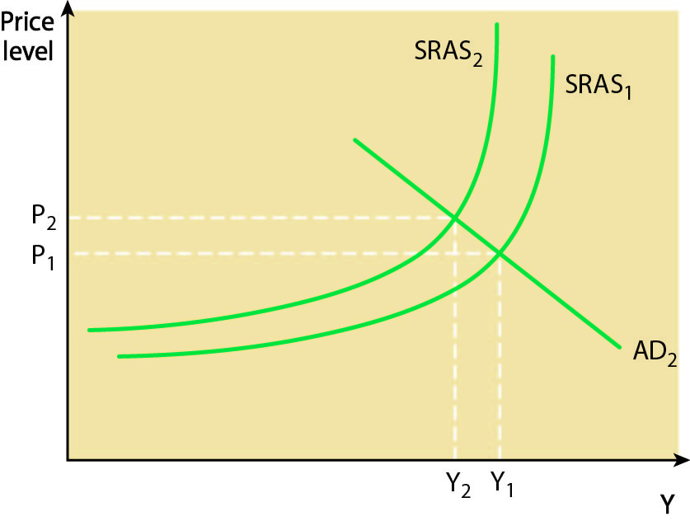
Up to 6 further marks can be awarded for an explanation of the effects on the economy. Relevant points would include:
- higher costs leading to higher inflation
- lower level of GDP
- higher level of unemployment
- likely policy response to reduce inflation (possibly)
- likely fall in less competitive exports [10]

