AQA AS Economics exam practice answers
7 How the macroeconomy works
1 The multiplier occurs where a change in a component of aggregate demand leads to a proportionately larger change in national income. The formula would also be acceptable as an answer. [3]
2 Multiplier = change in income/change in AD = £6bn/£1.5bn = 4 [4]
3 Up to 4 marks for the following diagram:

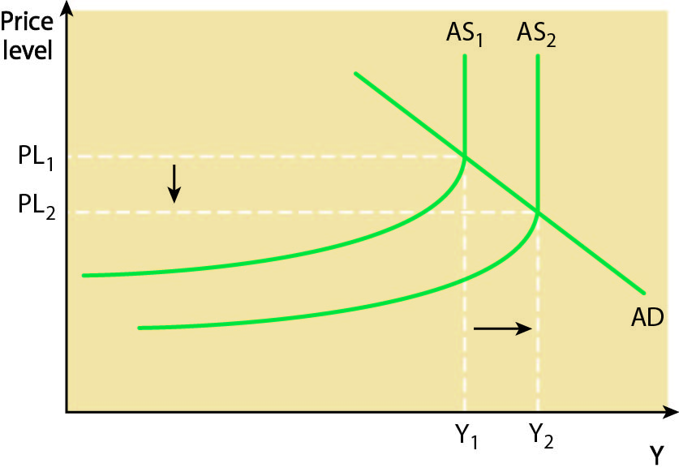
Up to 4 marks for the following analysis of issues. Points raised may include:
- multiplier effects on national income
- effects on unemployment/employment
- effects on inflation [8]
4 Marks will be awarded for the development of explanations of relevant factors. These may include:
- lower interest rates
- tax breaks
- providing a stable macroeconomic environment
- rising national income (as a result of accelerator)
- lower taxes on business profits [10]

