AQA AS Economics exam practice answers
5 The market mechanism, market failure and government intervention in markets
1 Correct answer: C create negative externalities [1]
2 Correct answer: C a demerit good [1]
3 Correct answer: A provides public goods [1]
4 Correct answer: D improving the availability of information to consumers [1]
5 (a) A good that would be over-consumed in a free market, e.g. alcohol, tobacco, unhealthy food [3]
(b) Diagram is as follows:

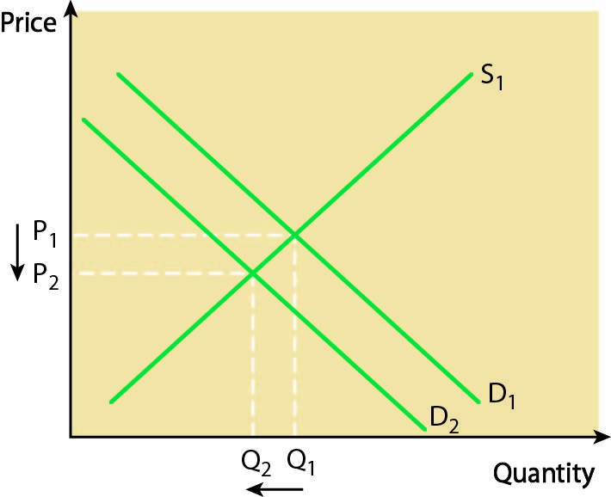

A correct diagram gains 4 marks; examiners will also credit one drawn with MSC = MPC, MPB > MSB.
Relevant points include:
- over-consumption arising from people being unable to appreciate the long-term costs to themselves and to society; unhealthy food being too cheap
- information failure
- definition and explanation of nature of demerit goods [8]

6 A correct diagram, as below, earns 4 marks:
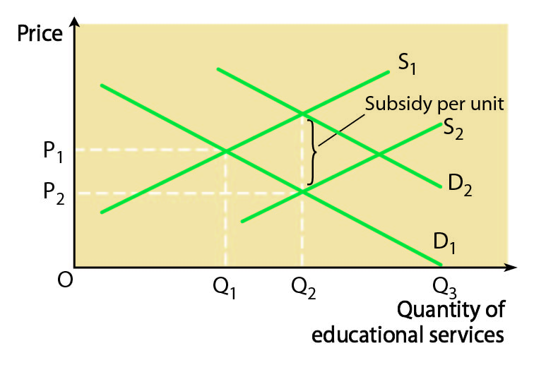
Relevant analysis includes:
- definition of a merit good
- definition of a subsidy
- explanation of how a subsidy encourages greater provision and consumption by reducing price and increasing supply [8]
7 Relevant points for analysis include:
- definition of merit goods
- accurate diagram
- reasons for under-consumption — people are unable to appreciate the long-term benefits to themselves and to society; education too expensive in a free market
- information failure
- methods of intervention, e.g. maximum prices, government provision, subsidy, correcting information failure

Relevant points for evaluation include:
- strengths and potential drawbacks of each method of intervention
- overall judgement
- scope for government failure [25]

