AQA AS Economics exam practice answers
4 Competitive and concentrated markets

1 Relevant points include:
- definition of profit maximisation, sales maximisation, growth maximisation and survival
- explanation of alternative objectives of profit maximisation [4]
2 Features include:
- large number of firms and buyers
- perfect knowledge
- no barriers to entry/exit
- homogeneous products
- firms are price takers [4]
3 A correct diagram, as below, earns 4 marks:
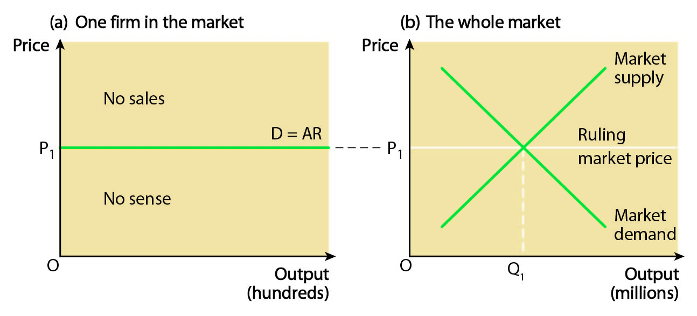
Points for analysis include:
- definition of a competitive market
- features of competitive markets
- how lack of price-setting power leads to a perfectly elastic demand curve at the equilibrium market price [8]
4 A correct diagram, as below, earns 4 marks:
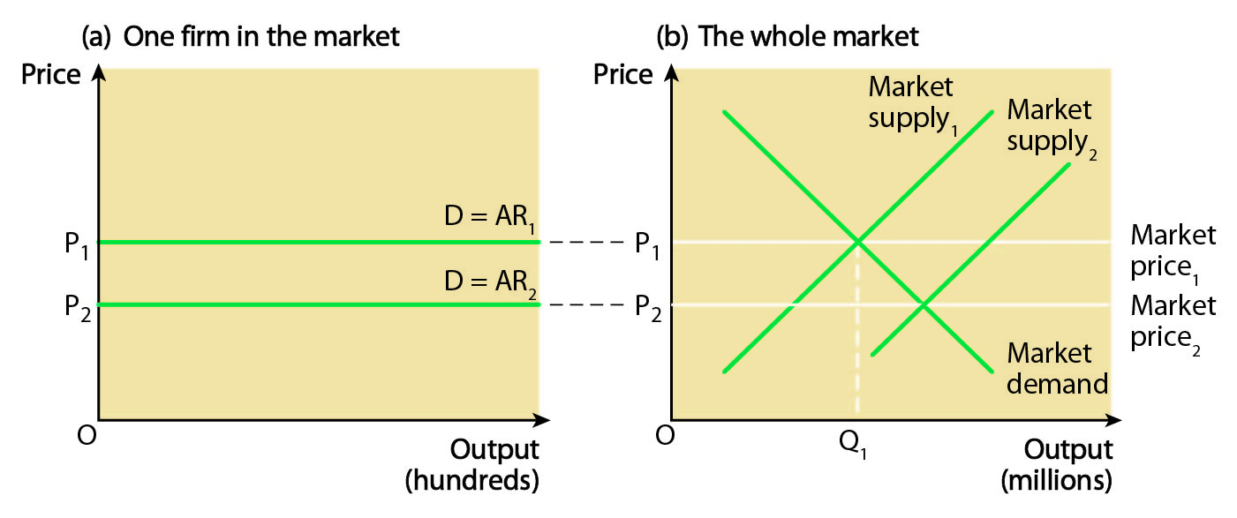
Points for analysis include:
- definition of a competitive market
- features of a competitive market
- increase in market supply leads to a reduction in price, which individual firms are obliged to take [8]
5 A correct diagram, as below, earns 4 marks:
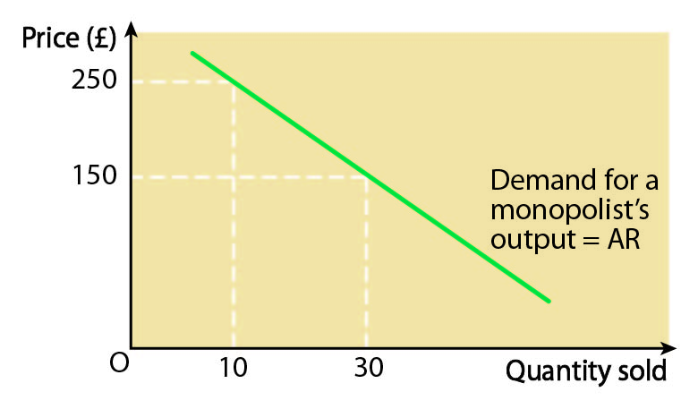
Points for analysis include:
- definition of a concentrated market
- examples of a concentrated market
- restriction of output in order to raise price [8]

6 (15.6 + 13.2 + 11.4 + 11.2 + 10.1)/5 = 61.5:5 (or 61.5%) [2]
7 (a) Relevant points include:
- definition of a highly concentrated market
- price competition, e.g. price war
- non-price competition, e.g. loyalty cards, quality of service, branding/advertising [4]
(b) Relevant points include:
- price competition, e.g. price war
- non-price competition, e.g. loyalty cards, quality of service, branding/advertising
- collusion between firms to deter a new competitor [4]

