AQA AS Economics exam practice answers
3 Production, costs and revenue
1 Correct answer: C an increase in new capital equipment in the industry [1]
2 The completed table showing the productivity of the four firms should read as follows: [4]

Firm | Total output (units) | Number of employees | Productivity (output per employee)
A | 140 | 7 | 20
B | 350 | 25 | 14
C | 88 | 11 | 8
D | 261 | 9 | 29
3 Relevant points include:
- definitions of specialisation, division of labour and productivity
- benefits of repetition
- making best use of skills/aptitudes
- it becomes more practical to equip workers with specialist capital equipment [4]
4 A correct diagram, as below, earns 4 marks:
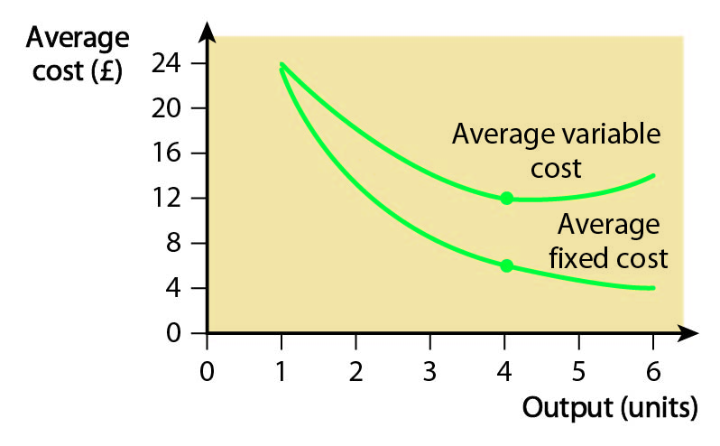
Points for analysis include:
- definition/explanation of short run, fixed costs and variable costs
- continually downward-sloping AFC curve as overheads spread over increasing output
- more U-shaped AVC curve as productivity of variable factors of production initially increases and then decreases [6]
5 A correct diagram, as below, earns 4 marks:
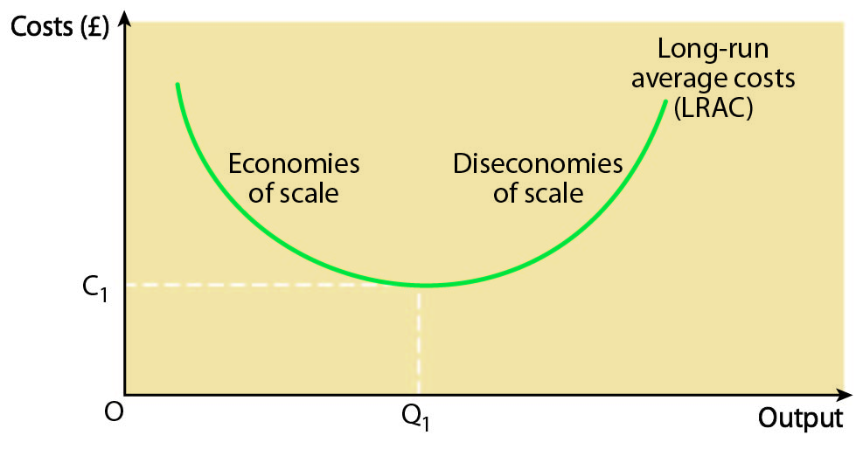
Points for analysis include:
- definition of long run, economies of scale and diseconomies of scale
- reasons for falling LRAC, e.g. technical, financial, marketing, external economies of scale
- reasons for possible eventual rising LRAC: sources of diseconomies of scale [8]
6 Relevant points include:
- definition of economies of scale
- relevant diagram
- application of technical, financial, marketing, managerial or external economies of scale to the airline industry [8]

