AQA AS Economics exam practice answers
2 Price determination in a competitive market
1 Correct answer: C a rise in consumers’ real incomes [1]
2 Correct answer: C technological improvements in milk production [1]
3 Correct answer: B a reduction in supply of oil from Middle Eastern countries [1]
4 Correct answer: D negative [1]
5 Correct answer: D Holidays in the UK are an inferior good while foreign holidays are a normal good. [1]
6 Correct answer: B a decrease in the price of a good with price elastic demand [1]
7 A correct diagram, as below, earns 4 marks:
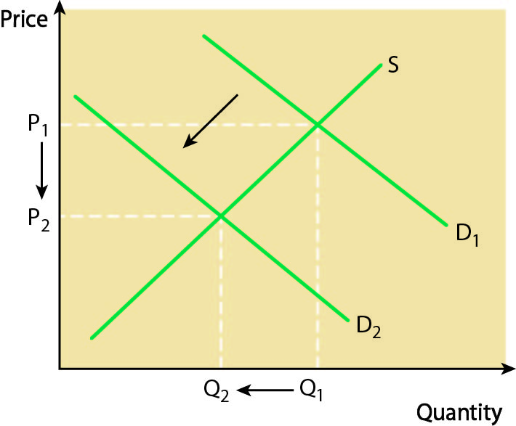
Relevant points for analysis include:
- definition of complementary goods
- explanation of the interrelationship between the two markets — petrol and cars
- explanation of how excess supply is created at price P₁ and how disequilibrium is resolved by the market mechanism [8]

