AQA AS/A-level Year 1 Biology exam practice answers
4 Genetic information, variation and relationships between organisms
1 Domain, kingdom, phylum, class, order (all five needed for 1 mark).
2 (a) Any three from: human/human DNA has the most base sequences in common; so it has the most complementary bases; and the most hydrogen bonds; making the two strands harder to separate.
(b) (i) Orang utan
(ii) Any two from: human/orang utan DNA denatures at the lowest temperature; so it has the fewest hydrogen bonds; and so it has the fewest base sequences in common; (because the longest time has elapsed since there was a common ancestor and so there has been more time for mutations to make differences in base sequences).
3 (a) It is present in all species.
(b) 104 × 3 = 312 (or 318 if you include the start and stop codons).
(c) Most genes contain introns (base sequences that do not code for the protein).
(d) (i) Fruit fly
(ii) Fruit flies have the most differences in amino acids sequence; so had the most distant common ancestor; so there has been the longest time for mutation to create amino acid differences.
(e) For: they do appear to be more distantly related: 15 differences compared with 14. Against: mutation is a random process, so measuring relatedness like this is not totally reliable
4 (a) Without bias (without conscious choice on the part of the experimenter).
(b) Habitat A, because evenness refers to how close each species is in terms of numbers.
(c) $d=\frac{N\left(N-1\right)}{Σn\left(n-1\right)}=94 ×\frac{93}{484}=1.17$
(d) Any three from: use of pesticides/herbicides; deforestation; agriculture/monoculture; hunting/trapping.
5
 | Mitosis | Meiosis
DNA replicates | ✓ | ✓
Chromosome number is maintained | ✓ | ✗
Homologous chromosomes pair up | ✗ | ✓

6 (a)
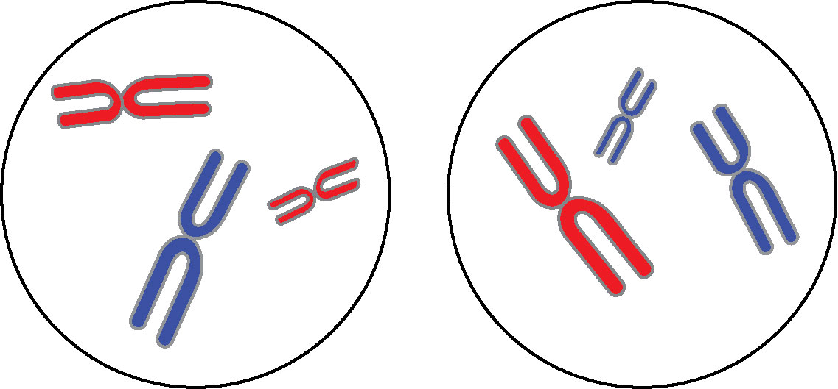

(b)
