AQA AS/A-level Year 1 Chemistry exam practice answers
5 Kinetics
1 (a) The minimum energy required for reaction to take place [1]
(b) [1] for each labelling point
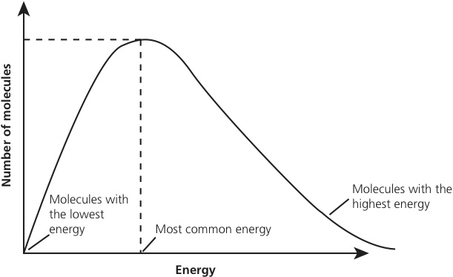
(c)
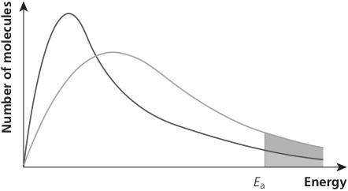
Highest point on curve is lower [1]; distribution moves to the right [1]
(d) As temperature increases, more particles have energy greater than the activation energy [1]; approximately double the area beyond the activation energy with the higher temperature graph [1]
2 (a)
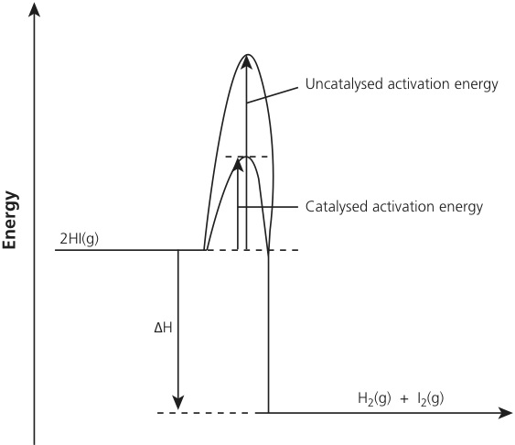
(b) E_{a} uncatalysed = 52 + 183 = 235 kJ mol⁻¹ [1]
E_{a} catalysed = 52 + 105 = 157 kJ mol⁻¹ [1]
(c) More particles per unit volume [1]; more effective collisions taking place per unit
time [1]
3 C
4 A

