AQA AS/A-level Year 1 Chemistry exam practice answers
3 Bonding
1 (a) A giant structure containing Na⁺ and Cl⁻ ions attracted electrostatically [1]
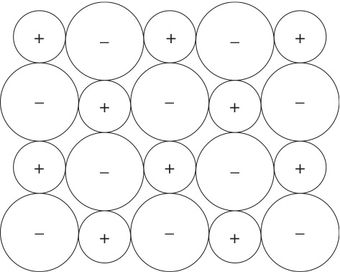 [1]
(b) (i) Ions are mobile in the liquid phase but fixed in their lattice in the solid phase [1]
(ii) Oppositely charged ions attract each other strongly [1]
2 (a) Shared [1] pair(s) [1] of electrons
(b) A covalent bond in which both electrons [1] being shared come from the same donor atom [1]
(c) A structure bonded throughout [1] by covalent bonds [1]
3 (a)
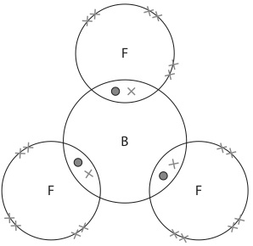 [2]
(b) An incomplete outer shell of six electrons [1]
(c) Ammonia has a lone pair of electrons [1] and may form a dative bond [1] in which the lone pair on the nitrogen atom is shared with the boron atom.
4 (a) Hydrogen bonding [1]; dipole–dipole attractions [1]
(b)
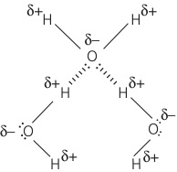
[1] for molecular shape being correct and intermolecular forces indicated with dipoles drawn; [1] for lone pairs drawn correctly with hydrogen bonding shown between a lone pair on an oxygen of one water molecule with a hydrogen atom from another water molecule
(c) Hydrogen bonds are stronger than dipole–dipole forces [1]; more energy is needed to separate the molecules [1]
(d) Increasing number of electrons in the molecules [1]; greater van der Waals’ forces [1]
5 B
6 A
7 C

