AQA AS/A-level Year 1 Chemistry exam practice answers
13 Alcohols
1 (a) 1: aqueous solution, yeast [1]; temperature around 35°C, anaerobic conditions [1]
2: concentrated sulfuric acid [1]; heat [1]
3: high pressure, high temperature, catalyst — all three points [2]
(b) Fermentation [1]; dehydration/elimination [1]; addition polymerisation [1] respectively
(c)
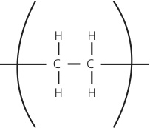 [1]
2 (a) 2-methylbutanal [1]
(b)
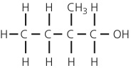 [1]
(c) Potassium dichromate(vi) and dilute sulfuric acid [1]
3 (a) A silver mirror would form [1]
(b)
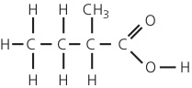 [1]
4 (a)
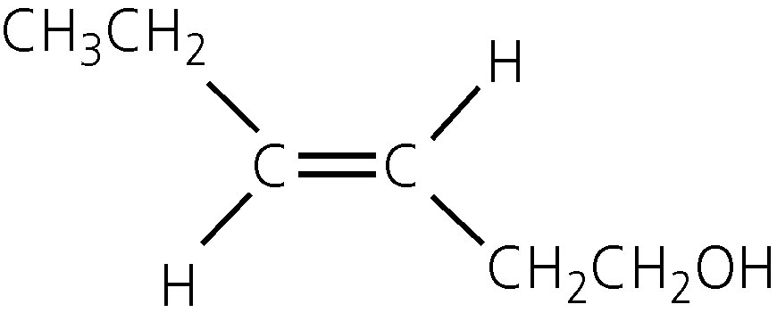[1]
(b)
[1]
(c) Stage 1: consider the groups joined to the right-hand carbon of the C=C bond
Consider the atomic number of the atoms attached [1]
C has a higher atomic number than H, so CH₂OH takes priority [1]
Stage 2: consider the groups joined to the left-hand carbon of the C=C bond
Both groups contain C atoms, so consider atoms one bond further away [1]
C, from ethyl group, has higher atomic number than H, from methyl group, so ethyl takes priority [1]
Stage 3: conclusion
The highest priority groups, ethyl and CH₂OH, are on same side of the C=C bond so the isomer is Z [1]
The rest of the IUPAC name is 3-methylpent-2-en-1-ol [1]

