AQA AS/A-level Year 1 Chemistry exam practice answers
12 Alkenes
1 (a) (i) Bromine water turns from orange to colourless [1]
(ii) No reaction — bromine water stays orange [1]
(b) Electrophilic addition [1]
(c)
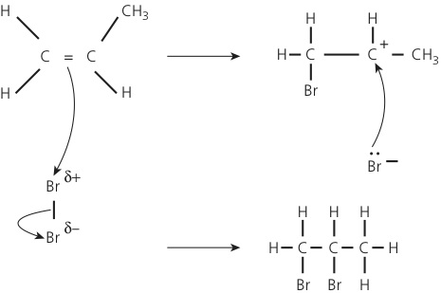 [1]
2 (a) 2-methylpropene [1]; but-1-ene [1]; E-but-2-ene [1] respectively
(b) C₄H₈ [1]
(c) Structural isomers [1]
(d) But-2-ene [1]; two different groups on different carbon atoms of the double bond/no free rotation allowed around the carbon double bond and so two different molecules exist [1]
(e)
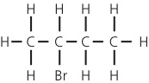 [1]
There are two possible carbocations:
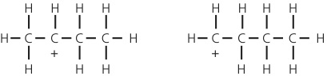 [1]
The secondary carbocation (the left-hand structure) is more stable than the primary one [1]
(f) (i)
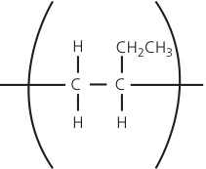 [1]
(ii)
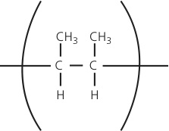 [1]
3 (a) Measured volume would be greater [1]
Level in burette falls as tap is filled before any liquid is delivered [1]
(b) Drop sizes vary [1]
(c) Use a larger single volume of oil [1]
Dissolve this oil in the organic solvent [1]
Transfer to a conical flask and make up to 250 cm³ with more solvent [1]
Titrate (25 cm³) samples from the flask [1]
(d) Stage 1:
mass of oil = 0.92 × (5.0 × 10⁻² × 5) = 0.23 (g) [1]
moles of oil = 0.23/885 = 2.6 × 10^{–4} [1]
Stage 2:
moles of bromine = (2.0 × 10⁻² × 39.4)/1000 = 7.9 × 10⁻⁴ [1]
Stage 3:
ratio oil:bromine = 2.6 × 10⁻⁴:7.9 × 10⁻⁴
simplest ratio = (2.6 × 10⁻⁴/2.6 × 10⁻⁴):(7.9 × 10⁻⁴/2.6 × 10⁻⁴) = 1:3 [1]
Hence, three C=C bonds [1]

