AQA AS/A-level Year 1 Chemistry exam practice answers

**11 Halogenoalkanes**

**1 (a) (i)** 1-bromobutane [1]

**(ii)** 2-bromo-2-methylpropane [1]

**(iii)** 2-bromobutane [1]

**(iv**) 1-bromo-2-methylpropane [1]

**(b) (i)** primary [1]

**(ii)** tertiary[1]

**(iii)** secondary [1]

**(iv)** primary [1]

**(c)** All are structural isomers of C4H9Br [1]

**(d) (i)**

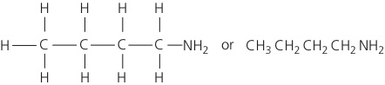 [1]

**(ii)**

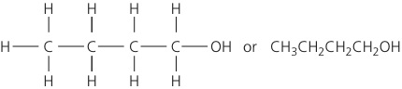[1]

**(iii)**

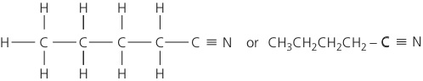 [1]

**(e)**

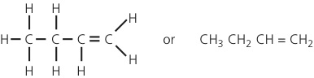 [1]

**(f)** Chloroethane would react more slowly [1]; the C–Cl bond is stronger than the   
C–Br bond [1]

**2** **(a)** UV light [1]

CCl4 → CCl3• + •Cl [1]

**(b)** Cl• + O3 → ClO• + O2 [1]

ClO• + O3 → Cl• + 2O2 [1]

**(c)** *M*r of CF3Cl = 104.5 [1]

moles of freon = (1.78 × 10−4 × 103)/104.5 = 1.67 × 10–3 [1]

number of molecules = 1.67 × 10–3 × 6.02 × 1023 = 1.01 × 1021 [1]

molecules in 500 cm3 = (1.01 × 1021 × 500 × 10–6)/100 = 5.04 × 1015 [1]

**3** D